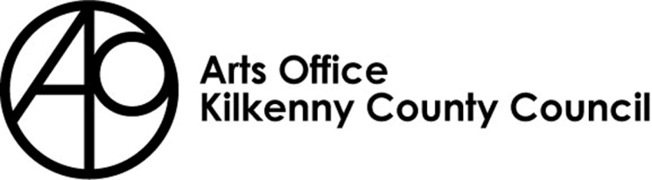

KILKENNY POETRY BROADSHEET 2023
ISSUE 23 - APPLICATION FORM

Kilkenny County Council Arts Office is inviting submissions from poets born or based in Kilkenny City and County for the 23rd Issue of Kilkenny Poetry Broadsheet.

We are delighted to announce that Afric McGlinchey will be editor of this year’s Broadsheet.
Afric was awarded the Hennessy Award for Emerging Poetry for 2010, the Northern Liberties Award (USA) in 2012 and the Poets Meet Politics Award in 2015. Named as one of Ireland’s Rising Poets by Poetry Ireland Review, she has received a number of awards from the Arts Council of Ireland, including two Literature Bursaries (2017 and 2022), a Covid-19 Bursary (2020) and an Agility Award (2021). In 2012, Salmon Poetry published The lucky star of hidden things, which evokes her nomadic upbringing between Ireland and Africa.
Rules of Submission

Submissions can be in English or Irish

Submissions must be the work of the entrant (no third party submissions)

Entrants must be 18 years of age or over

Limit of TWO entries per person.

Submissions MUST be typed and no longer than 30 lines

Work MUST NOT be signed

Entrants must be born or based in Kilkenny City or County

Submissions may have been published previously

Details of any such publication must be included with your application

The editor’s selection of published and shortlisted poems is final
- To be accepted for publication the editor may suggest edits to your poem/s for your consideration
- There is no submission fee but entries will not be returned

Please send submissions preferably in digital format (Microsoft Word) by email to deirdre.southey@kilkennycoco.ie . Hardcopy applications can still be submitted to: Kilkenny Arts Office, Johns Green House, Johns Green, Kilkenny.

The closing date for submissions: Friday 31st March 4pm

Further information 056 7794547

KILKENNY POETRY BROADSHEET ISSUE 23

APPLICATION FORM

Name in full (Block letters)

Postal address

________________________________________
________________________________________
________________________________________

Tel. Number

Email Address

Title of Work(s)

- ___________________________________
- __________________________________________

Have you had work(s) (those submitted here or otherwise)
published previously?
Yes No

_______________________________________________
_______________________________________________
_______________________________________________
_______________________________________________
_______________________________________________
_______________________________________________

If so, please give brief details

I consent to the holding and processing of my personal data for the purposes of this application only and I understand that it will not be used for any other purposes.
I confirm that I am 18 years of age or over and I was born or resident in Kilkenny.

Signed: ____________________________ Date:________________________________

