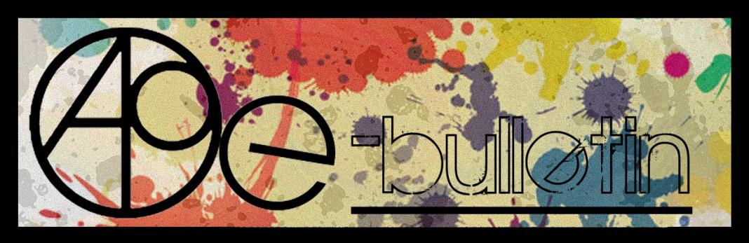

**Kilkenny County Council Arts Office E-bulletin 5th September 2014**

Dear All,   
  
Welcome to this week’s e-bulletin from Kilkenny County Council's Arts Office. Each bulletin is packed with the latest information on Kilkenny Arts Office activities, county events as well as news and opportunities for arts practitioners from around the country.

This service will be provided fortnightly. To include an item in the next e-bulletin please send a brief outline of your advert with relevant contact details, including any websites or pages with links to [**niamh.brophy@kilkennycoco.ie**](mailto:niamh.brophy@kilkennycoco.ie) **before 18th September**. The next e-bulletin will be on **19th September**.

While every effort has been made to ensure the accuracy of our information, we strongly advise readers to verify all details to their own satisfaction.

Regards,  
Niamh Brophy  
Arts Office,  
T: 056 7794138  
E: [niamh.brophy@kilkennycoco.ie](mailto:niamh.brophy@kilkennycoco.ie)   
W: [www.kilkennycoco.ie/eng/Services/Arts/](http://www.kilkennycoco.ie/eng/Services/Arts/)

BECOME PART OF IT, SUBMIT A POEM.....[www.rhymerag.net](http://kk-moss/Sites/arts_office/Shared%20Documents/Julianne%20Morgan/E-bulletin/30th%20May%20e-bulletin/www.rhymerag.net)  
Kilkenny County Council Arts Office Partner Local Authority of the ArtLinks Programme [www.artlinks.ie](http://www.artlinks.ie)

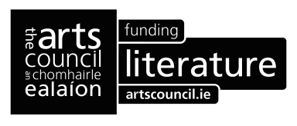

**Autumn 2014 Writers’ Workshop announced!**

**As part of our on-going commitment to Kilkenny writers, Kilkenny County Council Arts Office & Library Service would like to announce their adult Autumn 2014 Writers’ Workshop.**

**Creative Prose**

**Tutor: Ken Bourke  
Commencing Wednesday 17th September to Wednesday 26th November (excluding mid-term)**

**Duration: 10 weeks**

**Venue: City Library, John’s Quay, Kilkenny  
Time: 6pm - 8pm**

**Cost: €50**

The aim of the workshop is to give participants an opportunity to develop their prose-writing skills in a relaxed atmosphere. A typical session will involve periods of writing, reading/listening, and discussion. The workshop will focus on shorter prose forms, but we will also explore other aspects of story-telling. Participants will be encouraged to identify their personal writing objectives in terms of how, where, what, and when they will write. All levels of experience are welcome: the diversity of the group will be one of our key resources, and numbers will be limited to encourage full participation by all present.

*Ken Bourke has been a professional writer for over twenty years. He is an experienced facilitator and has worked with a wide range of groups. He lives in Kilkenny.*

**Reading and Writing Poetry: Getting Started**

**Tutor:** **Derek Coyle**

**Commencing Tuesday 23rd September to Tuesday 2nd December (excluding mid-term)**

**Duration: 10 weeks**

**Venue: Graiguenamanagh Library, Kilkenny  
Time: 6pm - 8pm**

**Cost: €50**

This course will get you writing poems. Participants will start plenty of new work in the course of the ten weeks. In the workshops you will learn what to look at in a poem from a writer’s point of view. You will work on developing your skills as makers of poems by learning how to read and examine carefully the work of other makers. You will learn some new words and techniques so that you can become more confident readers, and thus writers, of poetry. Participants will learn about line-breaks, couplets and quatrains, dramatic monologues, metaphor and simile. Along the way you will look at a selection of poems by well-established poets from Ireland and abroad: Eamon Grennan, Harry Clifton, Derek Walcott, Constantinos Cavafy, John Montague, Dermot Healey, Seamus Heaney, Nuala Ni Dhomhnaill, Kerry Hardie, Thom Gunn, Mark Doty, and Mary Oliver, to name a few.

**Deadline for Bookings is 4pm on Wednesday 10th September.**

**Participants are expected to sign up and commit to the 10 weeks of their chosen course. There is a nominal fee of €50 to secure your place in the course. Places are limited to 12 participants per course so please book early to avoid disappointment.**

**To secure a place on the above courses please contact the Arts Office on 056 7794938/ or email** [niamh.brophy@kilkennycoco.ie](mailto:niamh.brophy@kilkennycoco.ie)

**\_\_\_\_\_\_\_\_\_\_\_\_\_\_\_\_\_\_\_\_\_\_\_\_\_\_\_\_\_\_\_\_\_\_\_\_\_\_\_\_\_\_\_\_\_\_\_\_\_\_\_\_\_\_\_\_\_\_\_\_\_\_\_\_\_\_\_\_\_\_\_\_\_\_\_\_\_\_\_\_\_\_\_\_\_\_\_**

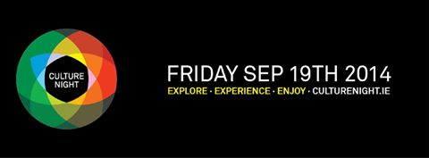

**Kilkenny celebrates with a wealth of cultural offerings on Friday 19th September**

**This is just a taster of what’s to come.....**

Following last year’s successful **FREES BEATS** programme, the Arts Office has once again curated an evening of music free to the public in various locations around the city. To name only a few performances - South East group **the Scenes** have been shortlisted as finalists in the International Songwriting Competition and the Hot Press Big Break Competition. They have shared stages with Madness, the Strypes, Fight Like Apes and Delorentos. the Scenes debut album is recorded and awaiting release in 2015. They will perform at the Town Hall from 6pm. Following them at 9pm, Kilkenny band **Crow Black Chicken** combines elements of folk, hard rock and the blues of bands like Gov't Mule to create their greasy blues rock sound. 2013 saw the band play Glastonbury and travel to Texas to tour and record tour with country blues legend Ray Wylie Hubbard. So far in 2014 *Crow Black Chicken* have had a No.12 album with’ Rumble Shake’. Australian-born musician **Margie Jean Lewis** returns to Kilkenny to play in Billy Byrne’s at 10pm, a myriad of antique instruments, experiments with field recordings, loops, electronic beats and tops things off with her rich, bewildering vocals. In Cleere’s from 10:30pm singer-songwriter **James Yorkston** will perform songs about life closer to home, fatherhood and the people dearest to his heart, many from his new eighth studio album ‘The Cellardyke Recording And Wassailing Society’. **The Midnight Union Band** are back on the Canal Square at 8:30pm. The band’s songs range from the most poetic and tender of ballads to fully fledged bustling tunes bursting at the seams with energy and rhythm.

**Open Circle** invites women from throughout Kilkenny to join them on Culture Night for the launch of the exhibition ‘**Social Fabric: Portraits of Kilkenny Women’** and to take part in the creation of a collaborative artwork facilitated by textile artist Deirdre Harte. This embroidery project is both collaborative and distinctly individual; a collection of portraits of Kilkenny women.The workshops will create a space in the lives of all who will take part to meet new people, chat, laugh, debate and create! There will also be a space for all the family to try out and learn a few embroidery stitches. An invited speaker will launch the exhibition at 6.30pm.Time: 6:30pm – 9pm**.** Venue: Johns Green, Kilkenny**.** Any enquires contact Carrie Lynam at [opencirclearts@gmail.com](mailto:opencirclearts@gmail.com)

Come to **Blackstack Studio** on Culture Night and learn all about the fine art of print! Your evening will be packed with dry point workshops, family friendly block printing workshops, silk screen print demos and a print exhibition. Learn all about dry point in a 40 minute workshop, where participants will have hands on experience of print. Bring the kids and learn how to make your own block print with Blackstack Studio member Vicky Cody, take home the step by step instructions and teach it to your family and friends. Culture Night participants will be able to take away a silk screen hand printed tote bag with them. There will also be a beautiful exhibition of prints made by members of the studio on display. Time: 5pm – 9 pm. Venue: 42 Parliament Street. Booking is required with places limited so book early. For all contact information please see [www.blackstackstudio.com](http://www.blackstackstudio.com)

The **National Craft Gallery** will host **‘Blown Beats’**, a cultural extravaganza of music and making, inspired by Resonance our innovative glass instrument and music exhibition. Kids can craft their own funky finger pianos and bizarre bazookas with musical maker Ed Devane; create melodies with our playful glass instruments; tinkle tunes with Ciara O’Sullivan’s collaborative clay bells and find their inner musician to raise the roof for a spectacular rhythmic finale with Beat Box king White Noise! Using everyday objects invent new bubble makers and fill the Castle Yard with gigantic rainbow bubbles! Bring your picnic and join the NCG in celebrating the Festival of Blown Beats! They will provide the picnic blankets, cushions, music and entertainment – including a symphonic performance from St Canices’ National School 87 piece Orchestra followed by a surprise guest appearance! Adults can enjoy a glass of wine and cheesy nibbles while children make rhythms, beats and dance to the music. \*Weather Permitting\* Time: 5pm – 9pm. Venue: National Craft Gallery. Any enquires contact Susan Holland - [events@nationalcraftgallery.ie](mailto:events@nationalcraftgallery.ie)

The **Arts Offices ‘Siamsa’** programme once again presents Professional artist Orla Bates and scientist Michelle Maher are back again for Culture Night to host a unique experience in their **‘Spark Studio’**. The studio provides the opportunity to learn about the world around us through the collaboration of really exciting art and science activities. It is a place to inspire and encourage children and adults to spend more time exploring, learning and sharing together. Is black really black? What does sound look like? Think of optical illusions, moving images and even the fact that we are seeing the world upside down! Discover what perception – bending illusions reveal about the way our senses ad brains interact with the world. Our studio explores intriguing ideas around light, vision, sound and includes all sorts of curious tools to encourage play and stimulate the imagination. Make a zoetrope and fool your minds into thinking static images are moving. Try drawing extraordinary geometric patterns with sound on the amazing Chaldni plates. Create illusions spinners and experience the magic of colour and light. Stop by and try them out together*.* Drop in / Drop out and try out a variety of activity which explore light, vision and sound. Time: 4pm – 8pm. Venue: Unit 2, Friary Street. Any enquiries contact [niamh.brophy@kilkennycoco.ie](mailto:niamh.brophy@kilkennycoco.ie)

We hope that Culture Night on Friday 19th September will encourage people to get into the habit of exploring the fantastic cultural facilities, events and opportunities that you'll find in Kilkenny. So please pick up a Culture Night Kilkenny 2014 programme at any of the venues of events, County Hall, Johns Green House, county libraries, book shops or cafes around the city closer to the date and make the most of what is free on offer!

Culture Night is brought to you by the Department of Arts, Heritage and the Gaeltacht in partnership with the Arts Office Kilkenny County Council.

The full programme of events and participating venues for Culture Night Kilkenny 2014 is available on [www.culturenight.ie](http://www.culturenight.ie) and [www.kilkennycoco.ie](http://www.kilkennycoco.ie) as well as the Facebook page ‘Culture Night Kilkenny’.

*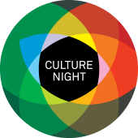  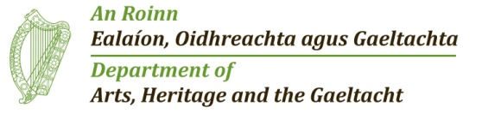*

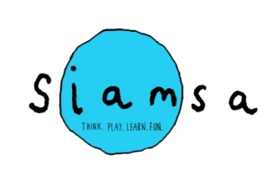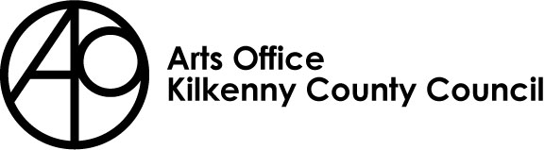

***“Now that your children have covered the laws of Physics, and environmental chemistry, we are now introducing then to energy, light and sound!”***

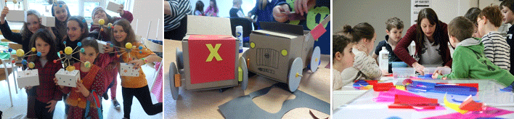

Kilkenny County Council Arts Office is delighted to announce its Autumn ‘Siamsa’ programme for 5 to12 year olds. This term a four week programme will run on Sunday’s 21st and 28th September and 5th and 12th October. Participants will join professional artist Órla Bates and scientist Michelle Maher for a unique experience in their **Spark Studio**. The studio provides the opportunity to learn about the world around us through the collaboration of really exciting art and science activities. The integration of art and science allows participants to express themselves creatively whilst really understanding difficult science concepts. It is a place to inspire and encourage enquiry, foster critical thinking and reward creativity.

‘Siamsa’ has been part of the Arts Office’s programme since 2011. This fun programme has supported children in developing numerous skills including drawing, painting and making in a diverse range of media. The workshops have included origami, clay modelling, Lego art as well as textile work. Our most recent workshop included arts and science working together covering the laws of physics and environmental chemistry. See a short film clip of Siamsa Spring 2014 activities here:

<http://youtu.be/U34xgnPNfQQ>

**Spark Studio** participants will be encouraged to answer questions to such as is black really black and what does sound look like? Think of optical illusions, moving images and even the fact that we are seeing the world upside down! Discover what perception-bending illusions reveal about the way our senses and brains interact with the world. Our studio explores intriguing ideas around light, vision and sound and includes all sorts of curious tools to encourage play and stimulate the imagination. Make a zoetrope and fool your mind into thinking static images are really moving. Try drawing extraordinary geometric patterns with sound on the amazing Chladni plates. Create illusion spinners and experience the magic of colour and light.

**Siamsa – 4 session workshop details**

**Age group: 5 to 12 year olds**

**Dates:** Sunday’s 21st and 28th September and 5th and 12th October

**Times: Group 1: 10am – 12.30pm**

**Group 2: 2pm – 4:30pm**

**Venue: 5 Dean Street, Kilkenny (beside Campion Framing)**

**Prices: Siamsa - 4 week programme:**

* **€40 for first child / €30 second child same family / €70 for 2 children same family**
* **Concessions €25 for first child / €15 second child same family / €40 for 2 children same family**

**Please mail:** [**niamh.brophy@kilkennycoco.ie**](mailto:niamh.brophy@kilkennycoco.ie) **for booking, ensuring you select which group you wish to book children(s) into.**

**BOOKINGS TAKEN BY E MAIL ONLY FROM 9AM ON FRIDAY 5TH SEPTEMBER**

**Early booking advisable as Siamsa is very popular and places are limited.**



 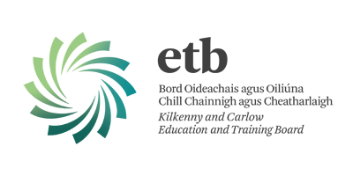 

**Short Story Creative Writing Weekend with ‘The Herbalist’ author Niamh Boyce**

As part of our on-going commitment to Kilkenny writers, Kilkenny County Council Arts Office and ETB Carlow / Kilkenny would like to announce a ‘Short Story Creative Writing Weekend’ with acclaimed author of ‘The Herbalist’ Niamh Boyce to take place on Saturday 13th and Sunday the 14th of September.

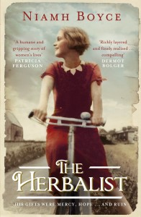

Over the two days Niamh Boyce will discuss a myriad of topics and exercises will be undertaken including: getting inspired and staying inspired; encouraging participants to follow their obsessions in writing; character and place setting and revelation; writing ‘as listening’ exercise; discussing the short story; flash fiction writing; and shared reading of work and individual critiquing with focused writing time.

Niamh Boyce is from Athy Co. Kildare. She writes novels, short stories and poetry. She won the overall Hennessy XO New Irish Writer of the Year and the Emerging Poet Category for her poem “Kitty”. Her unpublished poetry collection has since been highly commended in the Patrick Kavanagh Poetry Award 2013. Her bestselling first, The Herbalist (penguin Ireland) won newcomer of the year at the Irish Book Award 2013. She has had stories shortlisted for the Francis McManus Short Story competition 2011, The Hennessy Literary Awards 2010, The Molly Keane Award 2010 and the WOW award 2010. She has also been published in magazines such as the Moth, Crannog, Revival, Boyne Berries, The Stony Thursday Book and New Irish Writing Magazine.

**Dates:** Saturday 13th and Sunday the 14th September.

**Venue:** St. Mary’s Day Care Centre, Gaol Rd, Haughney Green, Kilkenny (behind Omniplex Cinema)

**Times:** 10am– 12pm writing session, 12pm – 1:30pm lunch and networking session, 1:30pm – 4pm writing session.

**Cost:** There is a nominal fee of €30 for your place in the course.

**Deadline for booking is 4pm on Monday 1st September.**

Places are limited to 12 participants so please book early to avoid disappointment.All levels of writing experience welcomed. Open to Kilkenny writers only.

**To secure a place on the above courses please contact the Arts Office on 056 7794138 or email** [niamh.brophy@kilkennycoco.ie](mailto:niamh.brophy@kilkennycoco.ie)

**\_\_\_\_\_\_\_\_\_\_\_\_\_\_\_\_\_\_\_\_\_\_\_\_\_\_\_\_\_\_\_\_\_\_\_\_\_\_\_\_\_\_\_\_\_\_\_\_\_\_\_\_\_\_\_\_\_\_\_\_\_\_\_\_\_\_\_\_\_\_\_\_\_\_\_\_\_\_\_\_\_\_\_\_\_\_\_**

**Kilkenny Events**

**\_\_\_\_\_\_\_\_\_\_\_\_\_\_\_\_\_\_\_\_\_\_\_\_\_\_\_\_\_\_\_\_\_\_\_\_\_\_\_\_\_\_\_\_\_\_\_\_\_\_\_\_\_\_\_\_\_\_\_\_\_\_\_\_\_\_\_\_\_\_\_\_\_\_\_\_\_\_\_\_\_\_\_\_\_\_\_**

## Young Irish Film Makers After School Workshops

## Inline image 1

## AFTER SCHOOL WORKSHOPS

## REGISTRATION DAY

Monday 22nd September (10:00am – 5:00pm)

YIFM Studios, St. Joseph's, Waterford Road, Kilkenny

T: 05677 64677

**COST:**€80 for 10 week term

**Classes Start:**

* Tuesday 24th September for Juniors
* Wednesday 25th September for Seniors

**TUESDAYS 4-6pm**

Juniors (9-12yrs)

**WEDS & FRI 4:30 – 6:30pm**

Seniors (13-18yrs)

## NEW TERM PROJECTS:

## Autumn Term – Drama production

## Spring – Film & Drama

## Summer – Open Door Policy – Personal & Group projects

## \*\*\*BIG NEWS\*\*\*

**NYCI YOUTH ARTS SHOWCASE:**

This year YIFM have been asked to bring 10 members of the cast and crew of the film ‘Still’ to Dublin to promote the work of YIFM.  YIFM candidates chosen to attend will speak to the Minister for Arts and other politicians about the importance of programmes such as Young Irish Film makers.

**TRIP TO INDIA:**

In April 2015, we are planning a trip to Calcutta, India with the senior group.  This trip is being planned in association with  [THE HOPE FOUNDATION](http://www.hopefoundation.ie/) as a film and photo documentary trip to promote the work of the foundation in helping street and slum children of Calcutta.  Provisionally booked for **April 2015 (dates to be confirmed)**, this unique trip will be a once in a lifetime experience for the young people involved.  **Spaces will be limited** and there will be a selection process put into place, so express your interest soon to make sure you are eligible to apply for a place.

**A taster course in the practice of dance, for all levels, from beginners up.**

No experience is necessary but willingness essential.

This course is a practical introduction to various elements of dance run by a range of practicing dance artists and guest teachers. It will touch on a variety of dance techniques, for example Somatic practices, and Laban technique. In its delivery it will instill qualities of self reliance, creative autonomy and mutual respect.

*-* Improve your fitness, flexibility and health.

* *Where do I go from here?:* Reflection and individual mentoring
* Explore the practice of dance:

*What is dance? How do I dance... by myself... with others?*

The course consists of 6 consecutive Fridays : September 19th -October 24th

9am – 4pm

Booking and info: KCAT 056 7755115

Numbers are limited so book by September 11th to avoid disapointment.

Tutors: Susie Lamb, Deirdre Grant, Lisa Cahill

**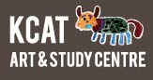**

**Susie Lamb**… Susie Lamb’s first trade is acting and she has acted in film, TV and theatre all over Ireland and abroad for 15 years. In 2008 she completed a three year training as a dancer and dance facilitator with Dancing the Rainbow and subsequently a one year programme with Myriad Dance, Wexford. She has been combining dance with theatre ever since. Her areas of speciality are stage presence in movement and dance for un-trained dancers. She is tutor in movement for performance in KCAT and is Participatory Dance Panel artist for Myriad dance.

**Deirdre Grant:** Guest Teacher: Deirdre was first introduced to contemporary dance through the Wexford Arts Centre, joining the Barefoot Youth Dance Company in 1984. She trained at Middlesex University, London were she obtained a BA Dance with Education. Since then, Deirdre has been developing contemporary dance regionally in Ireland, originally as a freelance dance artist and later through her work with Myriad Dance of which she is a founding member. After completing Studies with Joan Davis in Somatic Studies 2008, Deirdre began incorporating ideas from her experiences of Somatics  into both her performance and teaching contexts. She is an active member of the Artist in the Community Panel - a panel of inter-disciplinary artists, which represents the cream of best artists in arts practice in the county. She has 18 years of experience in teaching, devising performance projects for children, youth and special needs, incorporating her own blend of creative choreographic work and ideas into workshops with the public.

**\_\_\_\_\_\_\_\_\_\_\_\_\_\_\_\_\_\_\_\_\_\_\_\_\_\_\_\_\_\_\_\_\_\_\_\_\_\_\_\_\_\_\_\_\_\_\_\_\_\_\_\_\_\_\_\_\_\_\_\_\_\_\_\_\_\_\_\_\_\_\_\_\_\_\_\_\_\_\_\_\_\_\_\_\_\_**

**Music in Kilkenny presents**

**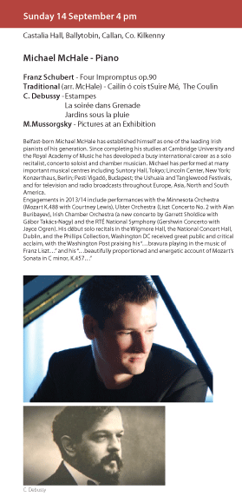**

**'CRAFT in Hand' Jerpoint Glass Attic Gallery (7 Aug - 30 Sept)**

[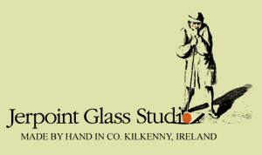](http://www.jerpointglass.com/)

'CRAFT in Hand' is an exhibition of work by nine local craftspeople curated by Jerpoint Glass Studios. Both Mark Campden and Caroline Dolan will be exhibiting work in the Glass Attic Gallery.

W: <http://www.jerpointglass.com/>

**\_\_\_\_\_\_\_\_\_\_\_\_\_\_\_\_\_\_\_\_\_\_\_\_\_\_\_\_\_\_\_\_\_\_\_\_\_\_\_\_\_\_\_\_\_\_\_\_\_\_\_\_\_\_\_\_\_\_\_\_\_\_\_\_\_\_\_\_\_\_\_\_\_\_\_\_\_\_\_\_\_\_\_\_\_\_**

**The Art of Meditation & Meditative Art**

Every Friday 10am – 1.30pm  
From 5th September – 21 November 2014

Aanahata Yoga and Healing Centre, Castlecomer Discovery Park, Castlecomer, Co. Kilkenny.  
Contact Gillian Campden 087 9738342 for more information on this new and exciting class or to book a space on either session

10.00 am-11.00 am Guided Meditation Session  
Learn to meditate and develop an Insight Practice where you can start to experience a greater sense of concentration, focus, calm, clarity, compassion and happiness. Suitable for all levels, including beginners.

11.15 am- 1.15 pm Meditative Art Class  
Develop or enhance your own creativity and style with appreciation of the nature of things as they are. learn to express yourself without any struggle of thoughts, hesitation or fear. Free yourself from the battle of the competative mind and the insecurities that brings, become free to express yourself. Suitable for all levels and experience, don’t worry if you have no previous experience but would love to paint, please come along and discover your hidden potential.

T: 087 9738342

[www.gilliancampden.com](http://lists.visualartists.ie/lt.php?c=1204&m=4243&nl=1&s=e784eec6bf8bb9680747b324b9c9eee1&lid=94098&l=-http--www.gilliancampden.com)

**Diana Chambers at the Watergarden Gallery Thomastown**  
  
Opening on Thursday September 11th at 3pm-All welcome!  
  
Only one year ago Diana started to paint. At first she copied famous artists: Matisse, Hopper, Chagall. But today you will see her original naive work: a mix of looking at a photograph, inventing and telling a story, sometimes writing. Of her work Diana says "I look at a picture [a photograph or a picture from a magazine] and then I paint, using crayons, paint and pens. I am laughing when I do my painting, says Mary." Diana is dynamic and immediate with her paintings.

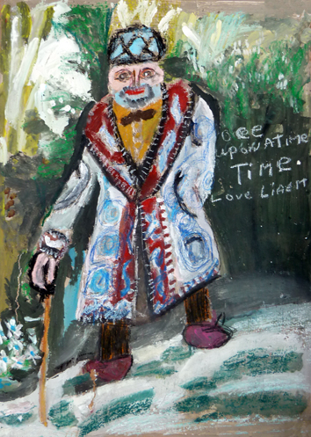

Diana was born 1954 in Dublin and lives since two years in Camphill Jerpoint.  
This year Diana will be a student in KCAT in Callan.  
  
The exhibition is at the Watergarden Gallery, Thomastown from 11th September 2014 for about 3 weeks.  
The Gallery is open during the normal business hours of The Watergarden Café (9.30am to 4.30pm, Tuesday to Friday, excluding Bank Holidays) and at other times by arrangement.

**Foróige: starting out training for volunteers (Kilkenny)**

Foróige relies on an amazing band of volunteers to keep our clubs, projects and programmes operating and providing our essential services. If you an interested in becoming a Foróige volunteer one of the first steps is to complete our recruitment process and attend Starting Out Training for Adult Volunteers.

This 10 hour course includes 4 hours on the NYCI accredited Child Protection Awareness Programme. The next training course is in September, the dates of which are as follows;

**Starting Out Training (6 hours)**

* Thursday 11th September 7.30pm – 9.30pm, the Drum Youth Centre, MacDonagh Junction, Kilkenny
* Thursday 18th September 7.30pm – 9.30pm, the Drum Youth Centre, MacDonagh Junction, Kilkenny
* Thursday 25th September 7.30pm – 9.30pm, the Drum Youth Centre, MacDonagh Junction, Kilkenny

**Child Protection Awareness Programme Training (4 hours)**

* Saturday 13th September 10.00am – 2.15pm, the Drum Youth Centre, MacDonagh Junction, Kilkenny

To book your place on this course please contact me on 086 2997677 or via email at [rosie.obrien@foroige.ie](mailto:rosie.obrien@foroige.ie) by Thursday 4th September 2014

Please note to gain your certificate in the course all sessions must be attended.

**\_\_\_\_\_\_\_\_\_\_\_\_\_\_\_\_\_\_\_\_\_\_\_\_\_\_\_\_\_\_\_\_\_\_\_\_\_\_\_\_\_\_\_\_\_\_\_\_\_\_\_\_\_\_\_\_\_\_\_\_\_\_\_\_\_\_\_\_\_\_\_\_\_\_\_\_\_\_\_\_\_\_\_\_\_\_\_**

**Information event on ‘Social Enterprise & How to Access Social Finance’**

Kilkenny LEADER Partnership (KLP) and UCIT (Ireland) Ltd would like to invite you to an information event on ‘Social Enterprise & How to Access Social Finance’.

The event will take place at 7.30 pm on Thursday the 18th of September in the Hotel Kilkenny in Kilkenny City.

Any community groups, specifically ones, with an interest in fund raising, grants and match fund loans for grants, should find it of interest.

For further information please see attached invitation.

As seating space is limited, I would be grateful if you could confirm attendance by either emailing [olive.doheny@cklp.ie](mailto:olive.doheny@cklp.ie) or phoning (056) 7752111 on or before Tuesday the 16th of September.

**Making Connections: Oral History and Community**

From tales of Cromwell to recollections of cinema-going in Belfast during the Troubles the 2014 Oral History Network of Ireland (OHNI) Conference has something for all oral history enthusiasts. ‘Making Connections: Oral History and Community’ will take place in the historic surrounds of Butler House, Kilkenny City from 12th – 13th September 2014.

This two day conference offers an exciting mix of training, workshops, presentations and discussion sessions, as well as ample opportunities to meet and network with fellow oral historians. We are delighted to confirm that our keynote speaker this year is Dr. Rob Perks, Lead Curator of Oral History in the British Library and Secretary of the Oral History Society in the UK. In addition, Dr. Perks will lead a workshop entitled ‘Archiving Oral History Recordings’. There will also be an ‘Ethics in Oral History’ workshop. Places for these workshops are limited so book early to avoid disappointment.

The focus of this year’s conference is the connections between oral history and community in its broadest sense. The conference programme reflects this emphasis with two ‘Moments in Oral History’ sessions dedicated specifically to community groups. The panel sessions include topics as diverse as music and performance, marginalised communities, rural and urban life stories and the challenges of collecting and disseminating oral history with modern technology. The conference will conclude with a panel examining the role of oral history within the heritage landscape in Ireland. Full details of the programme will be available on our website shortly.

Our speakers are drawn from every province of Ireland and further afield representing both academic and community-based oral historians. We invite all those practicing or with an interest in oral history and oral tradition including individual collectors, local community groups, curators, archivists, academics and policy practitioners to join us for a lively and stimulating conference in Kilkenny.

Registration for the conference is now open via our website, http://www.oralhistorynetworkireland.ie/2014-conference/. We have a range of registration options to suit all budgets including a special combined membership and conference rate. Places are limited, so please complete your registration early to avoid disappointment. For further information or queries email: info@oralhistorynetworkireland.ie.

**Library News**

**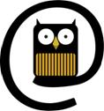**

Craft Group Workshops in Kilkenny Libraries

* City Library, John’s Quay: Tuesday evenings **6-8pm**
* Castlecomer Library: Thursday mornings, year round, **10-12pm**
* Graiguenamanagh Library: Wednesday mornings **10.30am to 12.30pm**
* Ferrybank library: Patchwork quilting – Tues morning at **11.45-1.20**

Knitting – Thurs mornings **10-12.00**(Both groups taking a break for the summer.)

We also have once off workshops e.g. Origami class **Wed 6th, 13th & 20th Aug – 11.30 -1pm**

Contact details for libraries:

<http://kilkennylibrary.kilkenny.ie/eng/Libraries_Locations/>

**\_\_\_\_\_\_\_\_\_\_\_\_\_\_\_\_\_\_\_\_\_\_\_\_\_\_\_\_\_\_\_\_\_\_\_\_\_\_\_\_\_\_\_\_\_\_\_\_\_\_\_\_\_\_\_\_\_\_\_\_\_\_\_\_\_\_\_\_\_\_\_\_\_\_\_\_\_\_\_\_\_\_\_\_\_\_**

**DCC Arts Office presents ‘Natura natura’ by Saidhbhín Gibson**

Natura natura  
26 August – 8 November  
The Cube Space, The LAB Gallery, Foley Street, Dublin 1  
Opening hours: Monday to Friday 10am – 6pm, Saturday 10am – 5pm  
The Natural History Museum, Merrion Street, Dublin 2  
Opening hours: Tuesday to Saturday 10am – 5pm, Sunday 2pm – 5pm

Dublin City Council Arts Office presents Natura natura by Saidhbhín Gibson.

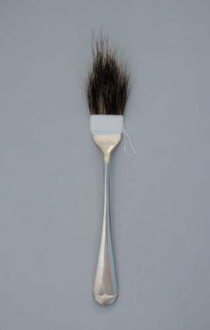

Dublin City Council Arts Office in collaboration with The Natural History Museum provided a temporary residency for artist Saidhbhín Gibson to explore the vast range of diverse species from the natural world featured in the museum’s exhibitions and collections.

The work developed in response to her residency, inspired by conversations with staff and time spent researching wildlife from Ireland, investigates our understanding and experience of nature in both rural and urban settings.

The exhibition is accompanied by a free programme of events at The LAB and The Natural History Museum exploring art and wildlife. For further information and bookings see: [http://naturanatura.eventbrite.ie](http://lists.visualartists.ie/lt.php?c=1200&m=4239&nl=1&s=d3c261c0eeb6b48867f449d29e09414b&lid=94004&l=-http--naturanatura.eventbrite.ie)

**Butler Gallery**

MARILYN LERNER**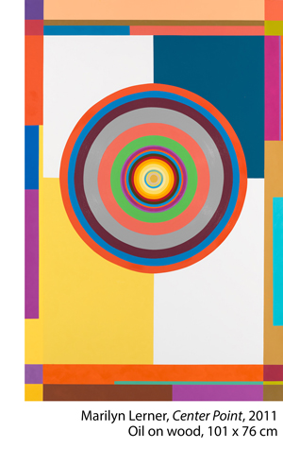  
August 9 – October 5, 2014**

The Butler Gallery is delighted to host Ireland’s first exhibition of the New York based painter Marilyn Lerner.

Lerner is an extraordinary artist who has been committed to making abstract geometric paintings for over forty years. Her oil paintings are painted on wooden panels with bevelled edges so that they almost float off the wall. They are highly skillful compositions that articulate her experiences through form, pattern and colour. Lerner has travelled extensively through North Africa and South East Asia and these trips have informed her work and made the language of geometry the focus of her work.

**\_\_\_\_\_\_\_\_\_\_\_\_\_\_\_\_\_\_\_\_\_\_\_\_\_\_\_\_\_\_\_\_\_\_\_\_\_\_\_\_\_\_\_\_\_\_\_\_\_\_\_\_\_\_\_\_\_\_\_\_\_\_\_\_\_\_\_\_\_\_\_\_\_\_\_\_\_\_\_\_\_\_\_\_\_\_\_**

### KOZO STUDIO is REOPENING in September 2014!

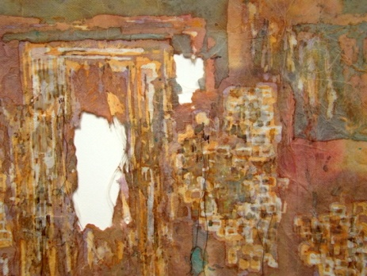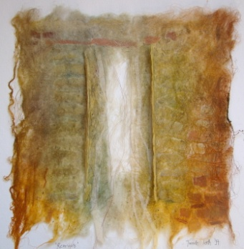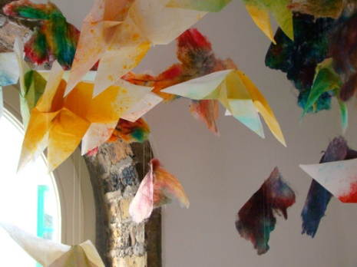​

Aafter more than 5 years KOZO STUDIO is REOPENING in September 2014!

Tunde Toth is starting a new studio and gallery space at the Estate Yard of Castlecomer Discovery  Park in Co. Kilkenny!

OPENING RECEPTION:

The Studio will be launched with **a solo exhibition of her new and recent works in mid -**September

- invitations and full info will be sent out to everyone on my mailing list very soon

Kozo Studio hopes to be a creative, inspiring space that will continue to organize art and craft workshops along arts events, interactive projects and participatory programmes.

So watch this space - an exiting programme is to follow!

Tunde Toth

[www.tundetoth.com](http://www.tundetoth.com/)

[www.tundetothpaperart.blogspot.com](http://www.tundetothpaperart.blogspot.com/)

### cid:ii_hz5op2470_147fe628ee8d47c0

**Barrow Consultancy and Training - Ongoing FETAC/QQI Courses**

Barrow Consultancy and Training - Ongoing FETAC/QQI Courses in Train the Trainer, Coaching, Supervisory Management and more…

Barrow Training – offer training programmes to companies and individuals in a wide range of areas.  
   
**We are currently offering:**

* Train the Trainer FETAC/QQI level 6 (Flyer attached)
* Professional Coaching Skills  FETAC/QQI level 6 (Flyer attached)
* Supervisory Management for Healthcare Managers FETAC/QQI level 6 (Flyer attached)
* Special Needs Assisting FETAC/QQI level 6 (Flyer attached)
* Non Violent Personal Safety and De-escalation Training  (Flyer attached)

Currently offering some special deals if you book online at [www.barrowtraining.ie](http://www.barrowtraining.ie/)

**Current schedule:** <http://www.barrowtraining.ie/schedule/>

**Region:**

Waterford, Wexford, Carlow, Kilkenny, Tipperary

**\_\_\_\_\_\_\_\_\_\_\_\_\_\_\_\_\_\_\_\_\_\_\_\_\_\_\_\_\_\_\_\_\_\_\_\_\_\_\_\_\_\_\_\_\_\_\_\_\_\_\_\_\_\_\_\_\_\_\_\_\_\_\_\_\_\_\_\_\_\_\_\_\_\_\_\_\_\_\_\_\_\_\_\_\_\_\_**

**Courses / Training / Jobs, Internships**

**\_\_\_\_\_\_\_\_\_\_\_\_\_\_\_\_\_\_\_\_\_\_\_\_\_\_\_\_\_\_\_\_\_\_\_\_\_\_\_\_\_\_\_\_\_\_\_\_\_\_\_\_\_\_\_\_\_\_\_\_\_\_\_\_\_\_\_\_\_\_\_\_\_\_\_\_\_\_\_\_\_\_\_\_\_\_\_**

**Lucinda Sly: Auditions**

Auditions will be held in October in Carlow for a new play, Lucinda Sly, set in the 1830's and based on the last public hanging of a woman - in Carlow - in 1835.

We require a cast of seven to nine actors.

The play will be rehearsed in Carlow in early 2015.

The play will open in the GBS Theatre, Carlow in late March 2015 and tour (mostly Thurs-Sat) between then and the end of May.

We require three females -

1. playing age 50's;

2. playing age 40's;

3. any playing age over 25

We require five males -

1. playing age 50 plus

2. playing age 40 plus

3. playing age 40 plus

4. playing age 30's

5. playing age 20's/30's

Please send a SHORT bio; a photo and contact details to: [lucindaslytheplay@gmail.com](mailto:lucindaslytheplay@gmail.com)

I will be in touch with all applicants by the end of September with audition details.

This is a profit share production.

**Association of Irish Festivals and Events (AOIFE): Masterclasses**

Masterclass 1:

On the 16th of September 2014 Jack Murray will provide a course on how to make your festival famous on a shoestring budget. The Class will take place in the Heritage Hotel in Portlaoise.

The course will cover:

* How the media works in Ireland.
* How set the communications objectives for your festival.
* How to organise a PR campaign.
* How to write a great press release.
* How to prepare a media list and send a media release at the right time.
* How to create great picture and how to use them.
* How to contact the media and get them interested in your festival.
* How to be creative when approaching the media.
* How to integrate social media into your PR plan.

For more on Jack Murray's masterclass visit AOIFE Blog

Masterclass 2:

Taking place in the Ulster Hall in Belfast and regards Festival and Event Management with Sylvia Allen and Colm Croffy.

On the 24th of September Colm Croffy and Sylvia Allen will be hosting a masterclass in the Ulster hall in Belfast. The masterclass will go into depth on festival and event management

The course will cover:

* Introductions and outline of modules
* Understanding Event / Festival Management
* Cash flow projections and pricing events. – making a budget
* Delivering Sustainability
* What Marketers want from Your Event
* How do you retain a valued Commercial supporter of the Festival / Event
* Marketing & Advertising Events on a shoestring budget
* Using Facebook/Twitter/Youtube to promote your festival/ event
* Dealing With Your Business Community
* Pitching the correct concept
* Sponsor Optimisation
* Follow Up – Post Event Report and A Renewals Strategy
* Public Relations for Your Event
* The Press Release
* A to Z of Press Relations
* Q&A session
* And Much more

For More info on Colm and Sylvia's Masterclass visit AOIFE blog.

[www.aoifeonline.com](http://www.aoifeonline.com/)

**‘Help! It doesn’t pay – YOU need to think about your artistic career’ | 1 Day Workshop at Centre for Creative Practices**

Sat 27th of Sep at 10am-5pm  
Admission: €50 / €45  
Centre for Creative Practices, 15 Pembroke Street Lower, Dublin 2

Have you been trying to make a living from your art?  
Have you been trying to get an audience for your art?

This 1 day workshop will give you a basic insight into how to change this, the steps you need to take and what results you are looking for. It will also ask you the question, why am I doing this, for whom and why? Define your purpose and impact.

[http://cfcp.ie/events/869](http://lists.visualartists.ie/lt.php?c=1204&m=4243&nl=1&s=e784eec6bf8bb9680747b324b9c9eee1&lid=94090&l=-http--cfcp.ie/events/869)

**One Day Workshop on Marketing for Artistic Entrepreneurship at Centre for Creative Practices**

Sat 27th of Sep at 10am-5pm  
Admission: €50 / €45  
Centre for Creative Practices, 15 Pembroke Street Lower, Dublin 2

This 1 day intensive workshop on marketing will cover a lot of ground.

By the end of the day you will have the outline of your marketing strategy and also be aware of new methods and ideas on marketing that are specific to the arts sector.

The workshop is suitable for artists, arts professionals and arts organisations looking to take their marketing to the next level.

[www.cfcp.ie/events/864](http://lists.visualartists.ie/lt.php?c=1204&m=4243&nl=1&s=e784eec6bf8bb9680747b324b9c9eee1&lid=94091&l=-http--www.cfcp.ie/events/864)

**CIT Crawford College of Art and Design: Creativity & change course**

[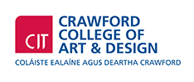](http://www.cit.ie/aboutcit/facultiescollegesanddepartments/citcrawfordcollegeofartanddesign/)

This is a CIT approved Special Purpose Award at Level 8 (10 credits) certificate supported by Irish Aid.

**ABOUT**  
Creativity & Change is about creativity and its power to ignite empathy, passion and learning about our interconnected and interdependent world.  
It is about imagining more humane, just and viable ways to live in the world. It connects how we think, live and act in the world and considers how we can live as connected global citizens becoming part of the changes we want to see.

**WHO IS IT FOR?**  
Artists, community workers, youth workers, activists educators, volunteers and anyone who is interested in exploring the connection between creativity, learning and change in the world and in nurturing possiblities to grow as connected global citizens.

**COURSE CONTENT**  
The course has several main strands of learning within the context of global citizenship & global and local justice themes.

* Development of confidence in personal creativity
* Creativity & learning strategies
* Creative strategies for public engagement.

**DURATION**  
Seven  2/3 day blocks Oct 2014 to May 2015

**APPLY**  
Applications accepted by email. Go website, [http://www.creativityandchange.info](http://www.creativityandchange.info/) and go to ‘get involved’ page to download application form. **Closing date: Sept 19th 2014**

**FEE**  
The course fee is subsidized through Irish Aid funding so it can be offered at reduced rate of €680

**ENQUIRIES**  
Enquiries to [creativityandchange@cit.ie](mailto:creativityandchange@cit.ie) or call Nora on 086 3765686

**WHAT PAST PARTICIPANTS HAVE SAID**  
*"I have a much greater understanding of how my own practice can be used as a means of critically examining the world/community around us, and also take away lots of practical skills and ideas“  
“One of the things that the course does best is combining theoretical knowledge with practical approaches and bridging the gap between those two areas. In doing so the course serves in itself as a great example."  
"It challenges the way you think and also many of the attitudes you have. This is done in a non confrontational way, self-reflecting way."  
"I got new energy...improved my understanding and expanded my horizons and opened my eyes to the world as a bigger picture."  
"Love that it can make learning fun even though the issues are very serious”  
“Very inspiring to see the power of art and creativity"*

[http://www.creativityandchange.info](http://www.creativityandchange.info/)

**\_\_\_\_\_\_\_\_\_\_\_\_\_\_\_\_\_\_\_\_\_\_\_\_\_\_\_\_\_\_\_\_\_\_\_\_\_\_\_\_\_\_\_\_\_\_\_\_\_\_\_\_\_\_\_\_\_\_\_\_\_\_\_\_\_\_\_\_\_\_\_\_\_\_\_\_\_\_\_\_\_\_\_\_\_\_\_**

**VAI: Professional Development Training Programme Autumn/Winter 2014**

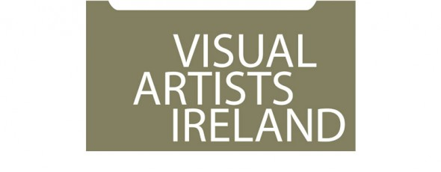

Visual Artists Ireland operates a wide range of professional development training and events throughout the year including **workshops, peer discussion groups, seminars and talks**. The delivery of this programme is greatly supported by our relationship with local and international visual art professionals and partner organisations throughout the island of Ireland. VAI works in partnership with Local Authorities, visual arts venues and others, combining resources to support the professional development of visual artists at regional level.

To register and for further information see: [http://visualartists.ie/professional-developmentp/](http://lists.visualartists.ie/lt.php?c=1191&m=4230&nl=1&s=d3c261c0eeb6b48867f449d29e09414b&lid=91545&l=-http--visualartists.ie/professional-developmentp/)

\*\*\*\*\*\*\*\*\*\*\*\*\*\*\*\*\*\*\*\*

**Dublin**

**Towards Sustainability – Mapping your Career** with Patricia Clyne-Kelly, John Daly and Brian Kennedy hosted *by Fingal Arts*

Thur. 9 Oct (10.30 – 16.30)

Venue to be confirmed

Places: 25 - 30

Cost: €60 / 30

[http://visualartists.ie/professional-developmentp/?ee=155](http://lists.visualartists.ie/lt.php?c=1191&m=4230&nl=1&s=d3c261c0eeb6b48867f449d29e09414b&lid=92517&l=-http--visualartists.ie/professional-developmentp/--Q-ee--E-155)

**Writing about Your Work** with Niamh O'Malley

Thur. 16 Oct (10.30 – 16.30) tbc

@ Visual Artists Ireland

Places: 10 - 12

Cost: €80 / 40 (VAI Members)

*Further information available on this session online in early Sept.*

**Developing Creative Proposals** with Annette Moloney

Wed. 19 Nov. (10.30 – 16.30)

@ Visual Artists Ireland

Places: 12 – 16

Cost: €80 / 40

[http://visualartists.ie/professional-developmentp/?ee=164](http://lists.visualartists.ie/lt.php?c=1191&m=4230&nl=1&s=d3c261c0eeb6b48867f449d29e09414b&lid=92518&l=-http--visualartists.ie/professional-developmentp/--Q-ee--E-164)

**Arts Council Funding Information Session -** Dublin

Wed. 5 Nov (time to be confirmed)

@Visual Artists Ireland

Places: 20 – 25

[http://visualartists.ie/professional-developmentp/?ee=166](http://lists.visualartists.ie/lt.php?c=1191&m=4230&nl=1&s=d3c261c0eeb6b48867f449d29e09414b&lid=92519&l=-http--visualartists.ie/professional-developmentp/--Q-ee--E-166)

\*\*\*\*\*\*\*\*\*\*\*\*\*\*\*\*\*\*\*\*

**Dundalk**

*Events in partnership with Creative Spark Louth*

**Socially Engaged Visual Art Practices** with Niamh O'Connor

Wed. 10 Sept (10.30 – 16.30)

@ Louth Creative Community Hub

Places: 10 - 12

Cost: €80 / 40 (VAI Members)

[http://visualartists.ie/professional-developmentp/?ee=152](http://lists.visualartists.ie/lt.php?c=1191&m=4230&nl=1&s=d3c261c0eeb6b48867f449d29e09414b&lid=92520&l=-http--visualartists.ie/professional-developmentp/--Q-ee--E-152)

**Presenting Yourself and Your Work** with Kerry McCall

Wed 17 Sept and Wed 24 Sept (2 half-day sessions)

@ Louth Creative Community Hub

Places: 10 - 12

Cost: €80 / 40 (VAI Members)

[http://visualartists.ie/professional-developmentp/?ee=150](http://lists.visualartists.ie/lt.php?c=1191&m=4230&nl=1&s=d3c261c0eeb6b48867f449d29e09414b&lid=92521&l=-http--visualartists.ie/professional-developmentp/--Q-ee--E-150)

**Developing Opportunities for your Work**

Date to be confirmed

@ Louth Creative Community Hub

*Further information available on this session online in early Sept.*

\*\*\*\*\*\*\*\*\*\*\*\*\*\*\*\*\*\*\*\*

**Galway**

*Event in partnership with Galway City & County Councils*

**Child Protection Awareness for Artists working with Young People** with Olive Ring

Wed. 3 Sept. (12.30 – 17.00)

@ Menlo Park Hotel, Galway City

Places: 12 - 20

Cost: *Free to Galway based artists*

[http://visualartists.ie/professional-developmentp/?ee=161](http://lists.visualartists.ie/lt.php?c=1191&m=4230&nl=1&s=d3c261c0eeb6b48867f449d29e09414b&lid=92522&l=-http--visualartists.ie/professional-developmentp/--Q-ee--E-161)

**Arts Council Funding Information Session** - Galway

Nov date (to be confrimed)

[http://visualartists.ie/professional-developmentp/?ee=168](http://lists.visualartists.ie/lt.php?c=1191&m=4230&nl=1&s=d3c261c0eeb6b48867f449d29e09414b&lid=92523&l=-http--visualartists.ie/professional-developmentp/--Q-ee--E-168)

\*\*\*\*\*\*\*\*\*\*\*\*\*\*\*\*\*\*\*\*

**Limerick**

*In partnership with LCGA, Limerick City & County Council and Clare and Tipperary County Councils*

**Developing Creative Proposals** with Annette Moloney

Tues. 21 Oct. (10.30 – 16.30)

Venue to be confirmed

Places: 12 - 16

Cost: €10 / 5 (VAI Members)

[http://visualartists.ie/professional-developmentp/?ee=162](http://lists.visualartists.ie/lt.php?c=1191&m=4230&nl=1&s=d3c261c0eeb6b48867f449d29e09414b&lid=92524&l=-http--visualartists.ie/professional-developmentp/--Q-ee--E-162)

\*\*\*\*\*\*\*\*\*\*\*\*\*\*\*\*\*\*\*\*

**Meath**

*Events in partnership with Meath County Council Arts Office*

**Presenting yourself & Your Work** with Patricia Clyne-Kelly

Tues. 18 Nov (10.30 – 16.30) tbc

Places: 10 - 12

Cost: €80 / 40 (VAI Members)

*Further information available on this session online in early Sept.*

**Developing Opportunities for your Work** with Elaine Grainger and Elaine Leader

Tues. 11 Nov (10.30 – 16.30)

Places: 15 - 20

Cost: €50 / 25 (VAI Members)

[http://visualartists.ie/professional-developmentp/?ee=158](http://lists.visualartists.ie/lt.php?c=1191&m=4230&nl=1&s=d3c261c0eeb6b48867f449d29e09414b&lid=92525&l=-http--visualartists.ie/professional-developmentp/--Q-ee--E-158)

**Documenting your Work** with Tim Durham

Date to be confirmed

Places: 10 - 12

Cost: €80 / 40 (VAI Members)

*Further information available on this session online in early Sept.*

\*\*\*\*\*\*\*\*\*\*\*\*\*\*\*\*\*\*\*\*

**Portloaise**

*In partnership with Dunamaise Arts Centre*

**Web and Social Media Strategies for Visual Artists** with Mary Carty

Fri. 5 Sept

@ Dunamaise Arts Centre

Places: 20

Cost: €60 / 30 (VAI Members)

[http://visualartists.ie/professional-developmentp/?ee=141](http://lists.visualartists.ie/lt.php?c=1191&m=4230&nl=1&s=d3c261c0eeb6b48867f449d29e09414b&lid=92526&l=-http--visualartists.ie/professional-developmentp/--Q-ee--E-141)

\*\*\*\*\*\*\*\*\*\*\*\*\*\*\*\*\*\*\*\*

**Roscommon**

*Event in partnership with Roscommon Visual Artists Forum*

**Presenting Yourself and Your Work** (half day) with Kerry McCall

Tues. 10 Sept (11.30 – 15.30)

@ Roscommon Arts Centre

Places: 10

[http://visualartists.ie/professional-developmentp/?ee=154](http://lists.visualartists.ie/lt.php?c=1191&m=4230&nl=1&s=d3c261c0eeb6b48867f449d29e09414b&lid=92527&l=-http--visualartists.ie/professional-developmentp/--Q-ee--E-154)

**Developing Opportunities for your Work** with Geraldine O'Reilly and Elaine Grainger

Thur. 2 Oct (11.30 – 17.00)

@ Roscommon Arts Centre

Places: 12 - 16

[http://visualartists.ie/professional-developmentp/?ee=153](http://lists.visualartists.ie/lt.php?c=1191&m=4230&nl=1&s=d3c261c0eeb6b48867f449d29e09414b&lid=92528&l=-http--visualartists.ie/professional-developmentp/--Q-ee--E-153)

**Protecting and Caring for Your Work** (half day) with Alan Ragget

Wed. 22 Oct (11.30 – 17.00)

@ King House, Boyle

Places: 15 - 20

[http://visualartists.ie/professional-developmentp/?ee=165](http://lists.visualartists.ie/lt.php?c=1191&m=4230&nl=1&s=d3c261c0eeb6b48867f449d29e09414b&lid=92529&l=-http--visualartists.ie/professional-developmentp/--Q-ee--E-165)

FREE to visual artists based in Roscommon

**Visiting Curators Sept & Nov, 2014**

**Dublin Live Art Fesitival**

In addition to these events above we also look forward to welcoming visiting Curators **Jonas Stampe** in September working in conjunction with the Dublin Live Art Festival.

**Bea de Souza** from The Agency Gallery London who will meet with artists connected with our regional partners in Galway in November.

**To register and for further information see:** [http://visualartists.ie/professional-developmentp/](http://lists.visualartists.ie/lt.php?c=1191&m=4230&nl=1&s=d3c261c0eeb6b48867f449d29e09414b&lid=91545&l=-http--visualartists.ie/professional-developmentp/)

 \*\*\*\*\*\*\*\*\*\*\*\*\*\*\*\*\*\*\*\*

**Bookings  Payments**

Booking and payment is required in advance for all sessions.  We encourage artists to register online where possible and if you wish to make payments off line following registration please do provide a mobile phone number on the registration form. We accept payment in the following ways: through PayPal online; by stg£ or Euro cheque made out to Visual Artists Ireland or by credit card over the phone.

If an event is not listed on our online system please email [monica@visualartists.ie](mailto:monica@visualartists.ie) to register interest in an event. State the full title of the event, the location and date and provide your name and mobile number in your email.   
  
To register online for Republic of Ireland training: [http://visualartists.ie/professional-developmentp/](http://lists.visualartists.ie/lt.php?c=1191&m=4230&nl=1&s=d3c261c0eeb6b48867f449d29e09414b&lid=91545&l=-http--visualartists.ie/professional-developmentp/)  
To register online for Northern Ireland training: [http://visualartists.org.uk/services/professionaldevelopment/current/](http://lists.visualartists.ie/lt.php?c=1191&m=4230&nl=1&s=d3c261c0eeb6b48867f449d29e09414b&lid=91546&l=-http--visualartists.org.uk/services/professionaldevelopment/current)

**Fees:**

VAI members receive preferential discount of 50% on fees for all training and professional development events.  
  
  
**Tell us about your training needs!**

If you are interested in training please do get in touch with us directly or forward an expression of interest in a topic/s through the Professional Development Training web page.  We often repeat workshops when there is a strong demand for a topic.    
  
**Artist & Tutors Panel**

Visual Artists Ireland has an ongoing open submission process for artists and arts professionals interested in being part of an available panel of tutors contributing to the VAI Professional Development Training Programme. For details go to our training registration page and click on Register for the PDT Artists Panel: [http://visualartists.ie/professional-developmentp/?ee=71](http://lists.visualartists.ie/lt.php?c=1191&m=4230&nl=1&s=d3c261c0eeb6b48867f449d29e09414b&lid=91547&l=-http--visualartists.ie/professional-developmentp/--Q-ee--E-71)

# National Youth Council of Ireland: Child Protection and Web Safety Training

#### [Child Protection Programme - National Youth Council of Ireland logo](http://www.childprotection.ie/)

#### [Websafety in Youth Work - Dublin](http://www.nycitraining.org/courses/websafety-youth-work-dublin)

Date: **15th September 2014**

**Description:** This 3.5 hour course is designed to raise awareness among youth leaders about young people’s online life, to identify on line risks and opportunities and to deal with cyberbullying. This training is supported by the free online resource website for youth workers <http://websafety.youth.ie/>  
**Venue:** Carmelite Centre, Dublin 2

#### [Child Protection Awareness Programme](http://www.nycitraining.org/courses/child-protection-awareness-programme-1)

Date: **24th September 2014**

**Training Event:** Child Protection Awareness Programme  
**Venue:** Carmelite Centre  
   
This four hour basic awareness course is the standardised child protection training programme for the youth work sector. It aims to create a basic awareness about the key issues in relation child protection. It is suitable for volunteers and staff members in youth work organisations.

#### [Websafety in Youth Work - Cork](http://www.nycitraining.org/courses/websafety-youth-work-cork)

Date: **1st December 2014**

**Description:** This 3.5 hour course is designed to raise awareness among youth leaders about young people’s online life, to identify on line risks and opportunities and to deal with cyberbullying. This training is supported by the free online resource website for youth workers <http://websafety.youth.ie/>  
   
**Venue:** Metropole Hotel, Cork

Please contact Geraldine Mahon at 01-4784122 to register or email [training@nyci.ie](mailto:training@nyci.ie)

**Training Programmes with Irish Times Training**  
  
Business to Arts Affiliates are eligible for discounts of up to 70% on programmes delivered by Irish Times Training.  
   
Popular upcoming courses include:

* [Report Writing](http://cts.vresp.com/c/?BusinesstoArts/0ed1120d3d/608128ad7e/adceaf3bdb) 18/19 Sept, €625 reduced to €250
* [Assertiveness Skills](http://cts.vresp.com/c/?BusinesstoArts/0ed1120d3d/608128ad7e/a38f885dad) 10/11 Sept, €625 reduced to €250
* [Dealing with the Media](http://cts.vresp.com/c/?BusinesstoArts/0ed1120d3d/608128ad7e/b28d94adb6) 25 Sept, €475 reduced to €250
* [Influencing & Persuading](http://cts.vresp.com/c/?BusinesstoArts/0ed1120d3d/608128ad7e/a16245b18c), 18 Sept, €395 reduced to €250
* [Minute Taking](http://cts.vresp.com/c/?BusinesstoArts/0ed1120d3d/608128ad7e/f9905aacc0) 3 Sept, €425 reduced to €250
* [Presentation Skills](http://cts.vresp.com/c/?BusinesstoArts/0ed1120d3d/608128ad7e/32415b79e9) 4/5 Sept, €625 reduced to €250
* [Time Management](http://cts.vresp.com/c/?BusinesstoArts/0ed1120d3d/608128ad7e/01500fbc03) 8 Sept, €425 reduced to €250
* [Negotiation Skills](http://cts.vresp.com/c/?BusinesstoArts/0ed1120d3d/608128ad7e/dc6d861e3d) 22/23 Sept, €650 reduced to €250
* [Finance for the non-Financial Manager](http://cts.vresp.com/c/?BusinesstoArts/0ed1120d3d/608128ad7e/9acb9636d3) 20/21 Oct, €750 reduced to €250
* [Chairing Meetings](http://cts.vresp.com/c/?BusinesstoArts/0ed1120d3d/608128ad7e/052d729706) 9 Sept, €425 reduced to €250

The Irish Times also have a series of well respected programmes in Digital Marketing, for which there is a 15% discount available for Business to Arts Affiliates.  
  
[Digital Marketing Evening Programme](http://cts.vresp.com/c/?BusinesstoArts/0ed1120d3d/608128ad7e/f150c8d0cb) Monday Evenings (6-9pm), 22 Sept- 15 Dec  
[Diploma in e-Commerce Management](http://cts.vresp.com/c/?BusinesstoArts/0ed1120d3d/608128ad7e/09d0469c8a) Tuesday Evenings (6-9pm), 16 Sept - 25 Nov  
  
Check the [Irish Times Training site](http://cts.vresp.com/c/?BusinesstoArts/0ed1120d3d/608128ad7e/97c2f4e8b6) for the complete list of courses. Discounts can only be secured for Business to Arts affiliates, and must be booked via our office. Email [Rowena](mailto:rowena@businesstoarts.ie?subject=Training%20Booking) if you would like to book a place on a programme.

### Lir, Ireland’s National Academy of Dramatic Art at Trinity College Dublin

[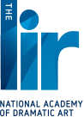](http://www.thelir.ie/)

Audition masterclass

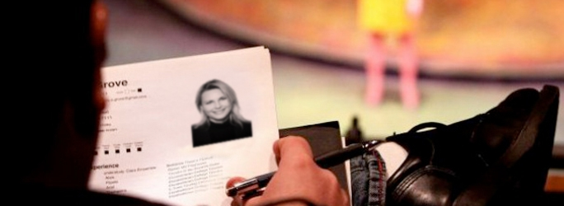

|  |  |  |  |
| --- | --- | --- | --- |
| Four days | **Sat 8th, Sun 9th, Sat 15th and Sun 16th November 2014** | 10.30am – 5.30pm | **€350** |
| Four days | **Sat 22nd, Sun 23rd, Sat 29th and Sun 30th November 2014** | 10.30am –5.30pm | **€350** |
| Four days | **Sat 6th, Sun 7th, Sat 13th and Sun 14th December 2014** | 10.30am - 5.30pm | **€350** |
| Four days | **Sat 17th, Sun 18th, Sat 24th and Sun 25th January 2015** | 10.30am - 5.30pm | **€350** |

### This is an intensive course for those considering auditioning for drama school and who wish to master audition technique and fully prepare their monologues.

More info at <http://www.thelir.ie/courses/view/audition-masterclass>

### The Master in Fine Art (Theatre Directing)

It was introduced following extensive consultation with the Irish theatre community and is a direct response to the stated needs of the industry and of talented emerging artists. The MFA programme aims to equip students of exceptional talent with the skills necessary to pursue a career in the professional theatre and related industries through the development of skills, professional practices and creative approaches to theatre directing.

More info at <http://www.thelir.ie/courses/view/master-in-fine-art-theatre-directing>

**\_\_\_\_\_\_\_\_\_\_\_\_\_\_\_\_\_\_\_\_\_\_\_\_\_\_\_\_\_\_\_\_\_\_\_\_\_\_\_\_\_\_\_\_\_\_\_\_\_\_\_\_\_\_\_\_\_\_\_\_\_\_\_\_\_\_\_\_\_\_\_\_\_\_\_\_\_\_\_\_\_\_\_\_\_\_\_**

**Call for Submissions / Residencies**

**\_\_\_\_\_\_\_\_\_\_\_\_\_\_\_\_\_\_\_\_\_\_\_\_\_\_\_\_\_\_\_\_\_\_\_\_\_\_\_\_\_\_\_\_\_\_\_\_\_\_\_\_\_\_\_\_\_\_\_\_\_\_\_\_\_\_\_\_\_\_\_\_\_\_\_\_\_\_\_\_\_\_\_\_\_\_\_**

**Public Art Commission - Stage 1 Expression of Interest**

Deadline: 8 October

Web: <http://www.cavanarts.ie/Default.aspx?StructureID_str=6&guid=91>

Email: [catrionaoreilly@cavancoco.ie](mailto:catrionaoreilly@cavancoco.ie)

Bailieborough BPttA Steering Committee is now inviting expressions of interest from artists or groups of artists for

a public artwork to be sited at the Market House, Bailieborough, County Cavan.

Front of the Market House (Library Building), Bailieborough, and view of proposed site to the side of the building

(disabled parking bays to be relocated).

The theme for this artwork is 'Forging Ahead'.

'Forging Ahead' - From Bailieborough's Divided Pasts towards our Shared Future'   acknowledges the segregation that once affected Bailieborough's communities, its industrial craft heritage and the determination of the community to shape a positive future. The people consider themselves to be resilient and determined and this attitude has shaped the development of the town and its many businesses and creative endeavours.

There is no payment to artists submitting the initial Expression of Interest (Stage 1). No more than 3 artists will be selected to proceed to Stage 2 and will be asked to develop a full proposal with sketches and a maquette. £500 is available for each artist selected for Stage 2.

Artists/Groups of Artists interested in submitting an Expression of Interest should read the following Artist Brief carefully and follow the guidelines for submission.

Bailieborough BPttA Artist Brief

The total value of the commission will be up to £40,000 (including VAT). This figure must also allow for all necessary design, treatment of surfaces, installation, erection and all fixings to secure the feature etc. There will be a six month timeframe for delivery of the artwork.

All queries should be directed via email only to Catriona O' Reilly at email address above

**Marymount University Hospital & Hospice: Percent for Art Commission**

Artists are invited to submit CV’s and images for consideration to be placed on a shortlist for creating a permanent outdoor artwork for the above well-known development for eldery care and palliative services. The aggregate value of the commission is €61,500.

It is an open brief for an outdoor permanent artwork in any medium, considered appropriate to outdoor exposure and longevity.

Deadline 4pm Friday 31 October 2014

Marymount University Hospital & Hospice, Curraheen, Co. Cork

For all details see: [www.marymount.ie](http://lists.visualartists.ie/lt.php?c=1204&m=4243&nl=1&s=e784eec6bf8bb9680747b324b9c9eee1&lid=94063&l=-http--www.marymount.ie)

**Applications for Project Studios, TBG+S**

Deadline: 15 October 2014

Web: <http://www.templebargallery.com/studios/apply>

Email: [info@templebargallery.com](mailto:info@templebargallery.com)

TBG+S is now accepting applications for Project Studios.

Project Studios are generally awarded to artists at an earlier point in their career, who demonstrate talent and potential.

Project Studios are awarded for one year in duration and do not confer company membership on the awardee.

Monthly studio rents at TBG+S are considerably subsidised and are inclusive of heating, electricity and WiFi.

Successful applicants will be informed by end October 2014

Artists must be available to take up residency at the beginning of January 2015

Applications for Project Studios 2014 must be made online.

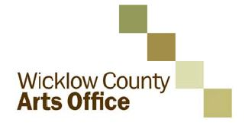

**Call for proposals: new initiatives for WCAO programme 2015**

As part of its plan for the development of the arts, Wicklow County Arts Office invites applications from interested parties for funding to develop and deliver new projects of high quality and impact during 2015 which will enhance and complement the strategic development of the arts in the County.

This call is open to organisations and individuals from any part of Ireland across all arts disciplines. Proposals should add significant value to arts practice, experience and/or participation in the arts in County Wicklow and support the Council’s strategic goals for the arts 2014-2016. 2015 is the second year that this initiative has been offered, for information on projects which were awarded in 2014 see [www.wicklow.ie](http://www.wicklow.ie), select Other Services and Arts Office. The information is under New Strategic Projects 2014. Projects include a new commission *Medicated Milk* for dance practitioner Áine Stapleton, a collaborative commission with Arklow Silver Band by composer Ian Wilson, a residency exchange between Wicklow and Cork based artists by Cork Printmakers and a series of Literary Events by Poetry IReladn.

Reflecting the balance of other elements of its programme, the Arts Office would particularly welcome strong applications in literature, film, architecture, and artist development. The Arts Office is also interested in proposals in the visual arts and music.

The Arts Office is particularly interested to hear from **national resource organisations, individual curators and artist** **collectives** who have the potential to propose projects which will nurture practice, create connectivity, generate new perspectives and voices within the cultural life of the county and support a diversity of approach.

The total amount of the fund available is subject to finalisation of Wicklow County Arts Office own funding for 2015, but is likely to be a maximum of €60,000. It is intended that a number of projects may be supported through this call to a maximum of €15,000.00 per project.

The closing date for applications is **4pm on Wednesday the 24th of September 2014**. Decisions will be made by Wicklow County Arts Office during September 2014 and applicants will be notified of the Arts Office decision shortly thereafter.

The application process is being managed for Wicklow County Arts Office by Interactions. Guidelines and application forms should downloaded from www.wicklow.ie under Other Services/Arts Office. Any queries on the application process should also be directed by email to: [wicklow@inter-actions.biz](mailto:wicklow@inter-actions.biz).

**Waterford Healing Arts Trust invites you to share your feel-good poetry and prose**

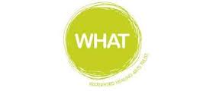

The Waterford Healing Arts Trust, Ireland’s leading arts and health programme, is inviting people to send them those pieces of poetry and prose that bring solace and joy in preparation for a public reading as part of the second Well Festival of Arts and Wellbeing in Waterford.

Cassandra Clare once said “it was books that made me feel that perhaps I was not completely alone” and it is in the spirit of this link between reading and wellbeing that the Waterford Healing Arts Trust is organising this very special event which they are calling ‘We haven’t had an earthquake lately…’ .

If you reach for a favourite poem or prose when you need cheering up, please e-mail it to [WHAT@hse.ie](mailto:WHAT@hse.ie) by **Wednesday 24 September** with ‘earthquake’ in the subject line.  State who the author is and why you chose it. Prose pieces should be no longer than 200 words.

A selection of submissions will be read at a public event in The Book Centre Waterford on World Mental Health Day, Friday 10 October at 6.30pm.

This is the second time that Waterford Healing Arts Trust is hosting this unique literary event which forms part of the programme of the Well Festival of Arts and Wellbeing.  The Well Festival, a joint initiative between Garter Lane and Waterford Healing Arts Trust, celebrates the benefits of participation in the arts for both individuals and the community. It is funded by the Arts Council and will run from 6 – 10 October.

For more information contact:

051-842664,

[WHAT@hse.ie](mailto:WHAT@hse.ie)

[www.waterfordhealingarts.com](http://www.waterfordhealingarts.com)

**The 2014 Plunkett Short Story Award**

**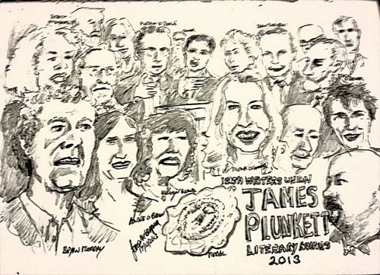**

Prizes: First Prize: **€2,000** / Second Prize: **€1,000** / Third Prize: **€500**

There is no restriction on theme or genre. Entrants are simply asked to recall Plunkett's skill as a social commentator when writing.

Closing date: **Friday, 12th September 2014**

Entries should be between 1,000 and 3,000 words

Entries should be addressed to: The Irish Writers' Union, 19 Parnell Square, Dublin 1

There is no limit on the number of submissions an entrant can make.

Entry costs **€10 per submission**. Please make cheques payable to the Irish Writers' Union.

A long list of 30 entries will be published on the website of the Irish Writers' Union before the winning entrants will be selected.

For more details, please visit [www.ireland-writers.com](http://r20.rs6.net/tn.jsp?f=001UJNU_4Udl_iojZmLs_IepzvH2QXBXuFT-fPIe6dgrajRDqQWMqXDuERTyxAXpZcrRTPu9ZNA6zd29TQc-_a7FAJR1t-Ke5M7cfdn8LAFdsDZPBWM3bVWcA_AmX3UNKM7vCrQFrC8pQfGQsXeCbDO5eX9gAT_66eiyIdXB2vwhm3Ea0afYW2ngQ==&c=it1jPOJakwM4WjPKopx6a3UZYGEgS4bpgWFoH7nUniAUyOPT6VTbRw==&ch=qm2z9y_QyA4gy4xlUkHhx8nE6M1dKjBj1WKa9L7-JjYpNNiWa6q8fw==)

**\_\_\_\_\_\_\_\_\_\_\_\_\_\_\_\_\_\_\_\_\_\_\_\_\_\_\_\_\_\_\_\_\_\_\_\_\_\_\_\_\_\_\_\_\_\_\_\_\_\_\_\_\_\_\_\_\_\_\_\_\_\_\_\_\_\_\_\_\_\_\_\_\_\_\_\_\_\_\_\_\_\_\_\_\_\_\_**

## [Open Call – Hospital Shop Window Festival (HSWF)](http://visualartists.ie/jobs-ops/opportunities-ireland/open-call-hospital-shop-window-festival-hswf/)

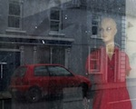

Hospital Shop Window Festival (HSWF) invites artists across all disciplines to submit work for their Festival which will be launched on Culture Night, **Friday 19 September, 2014** and run until Friday September 26, 2014.

The Festival will take place on the main street of Hospital, Co. Limerick and will utilize dormant and functional shop premises as showcases for visual arts with the aim of bringing art and culture to the street, allowing free and unrestricted access for all.

Works in any medium can be submitted. Up to a maximum of three works per artist may be submitted. There is NO submission fee.

For full details on the submission process please see [www.hswf.weebly.com](http://www.hswf.weebly.com)

Email: [hswf@outlook.com](http://www.kilkennycoco.ie/eng/Services/Arts/News/hswf@outlook.com)

**\_\_\_\_\_\_\_\_\_\_\_\_\_\_\_\_\_\_\_\_\_\_\_\_\_\_\_\_\_\_\_\_\_\_\_\_\_\_\_\_\_\_\_\_\_\_\_\_\_\_\_\_\_\_\_\_\_\_\_\_\_\_\_\_\_\_\_\_\_\_\_\_\_\_\_\_\_\_\_\_\_\_\_\_\_\_\_**

**The Little Museum 2016 Commissioning Programme**

**[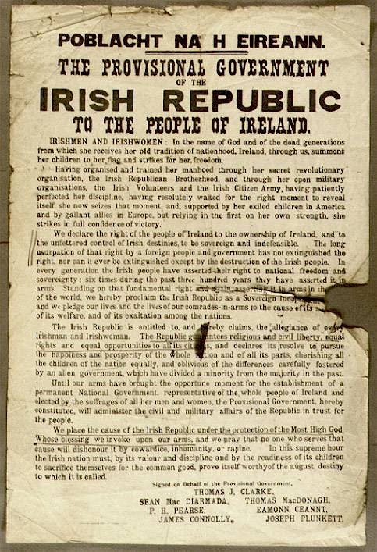](http://www.littlemuseum.ie/events/the-little-museum-2016-commissioning-programme/2152e9d20b)**

The Little Museum is delighted to announce a large scale commissioning programme to produce artworks for public exhibit in 2016. Inviting artists from all media, this exciting project will see the museum commission a large number of small scale art projects which will interrogate the history and legacy of the 1916 Rising and the individuals involved, as well as intersecting with present-day perspectives on commemoration, remembrance and the function of history as a component of civic awareness.

As a cultural institution whose primary goal is educational, the Little Museum is wary of providing simplistic accounts of the past. The archivist Catriona Crowe has spoken of the need to complicate the narrative during this decade of commemorations (which we are officially shortening to the Decorations). Taking Catriona’s advice as our cue, we want to create audacious public interventions that provoke, educate and entertain.

<http://www.littlemuseum.ie/events/the-little-museum-2016-commissioning-programme>

**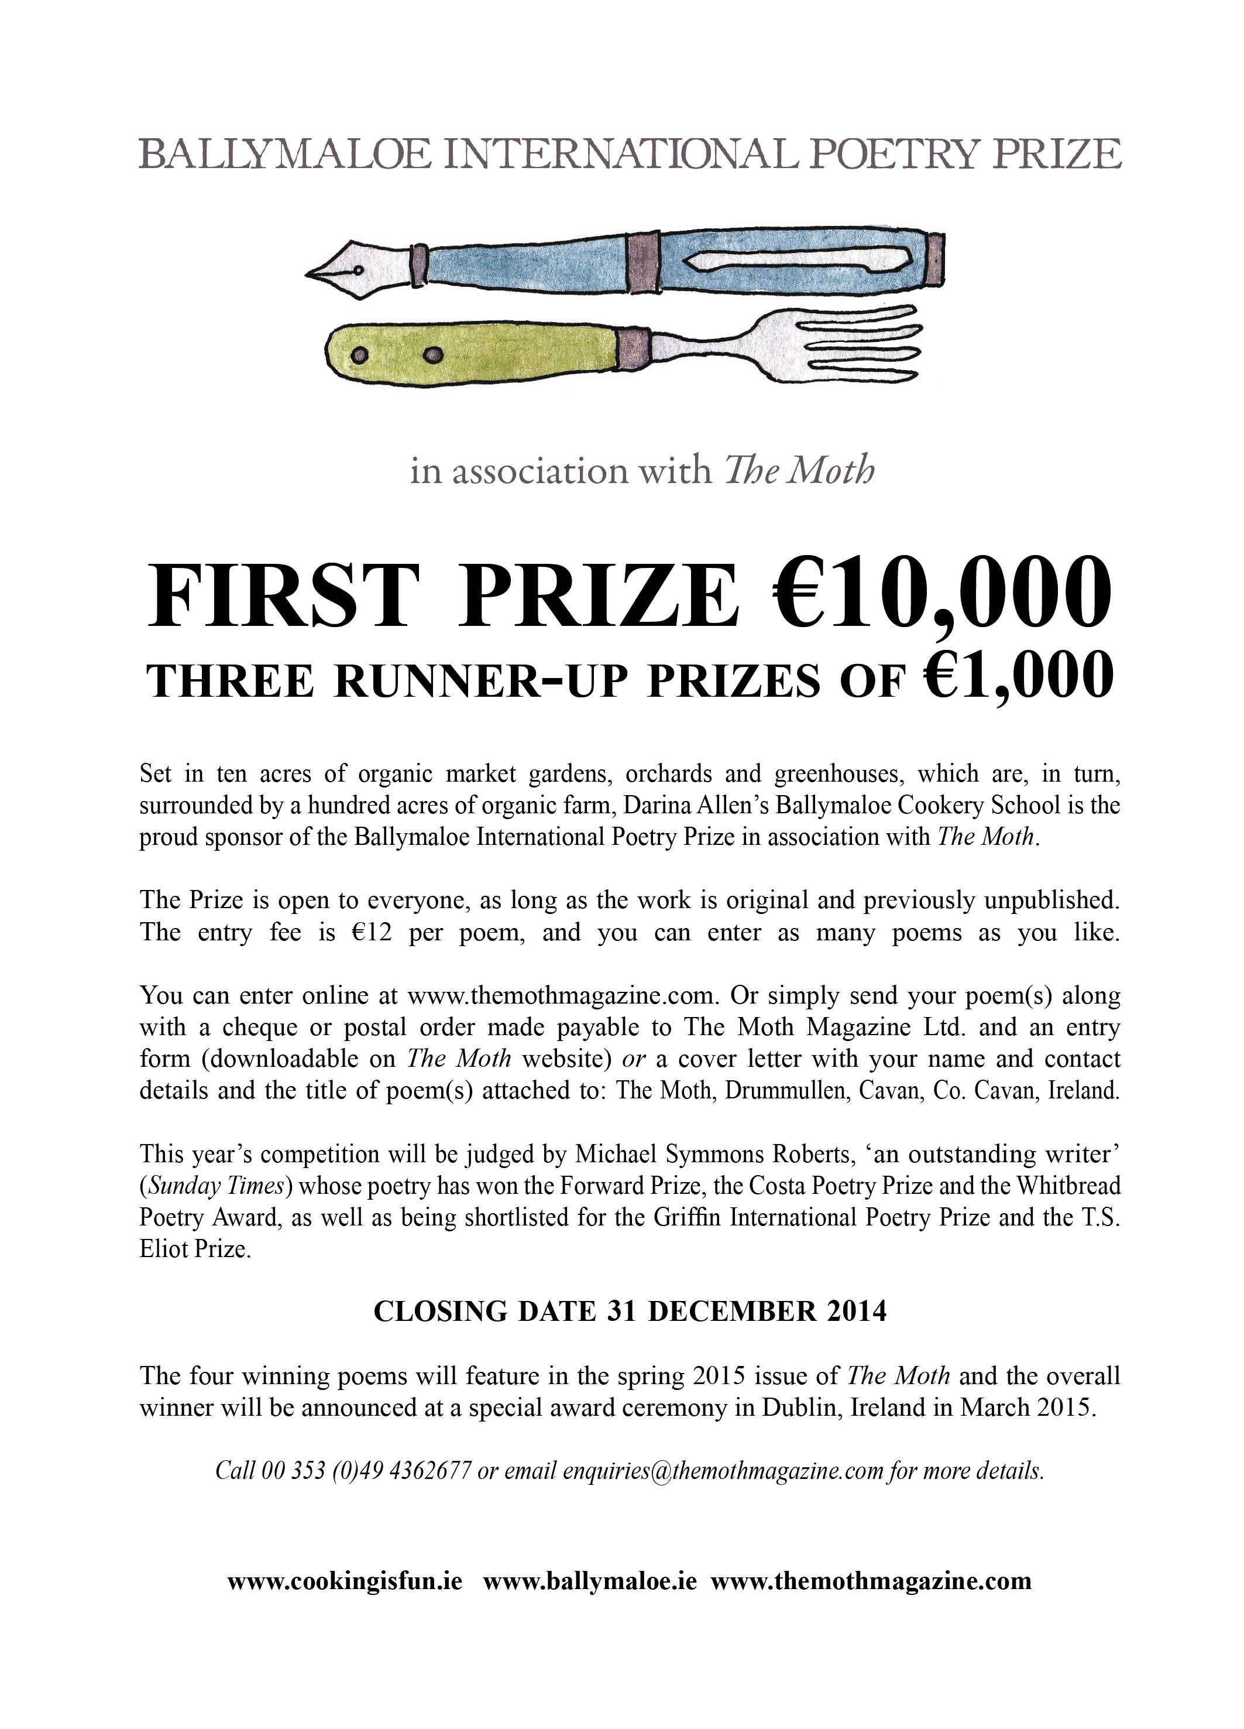**

**CUISLE YOUNG POET OF THE YEAR COMPETITION**

**Closing Date 29th September 2014**

**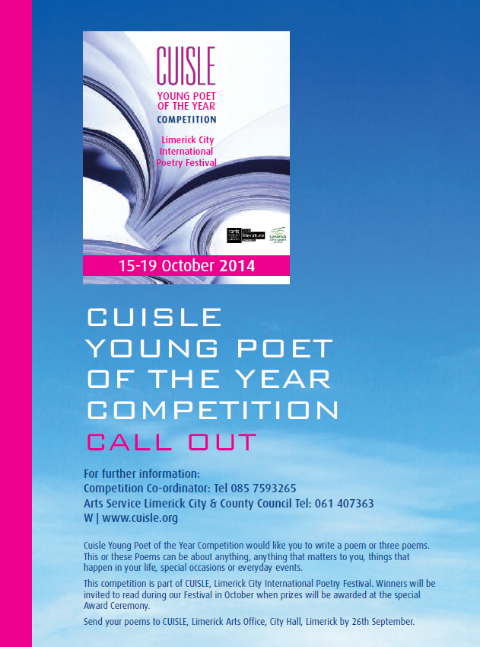**

CUISLE Young Poet of the Year Competition would like you to write a poem or three poems. This or these Poems can be about anything, anything that matters to you, things that happen in your life, special occasions or everyday events. This competition is part of CUISLE, Limerick City International Poetry Festival.

More info at <http://tinyurl.com/l84bncr>

## \_\_\_\_\_\_\_\_\_\_\_\_\_\_\_\_\_\_\_\_\_\_\_\_\_\_\_\_\_\_\_\_\_\_\_\_\_\_\_\_\_\_\_\_\_\_\_\_\_\_\_\_\_\_\_\_\_\_\_\_\_\_\_\_\_\_\_\_\_\_\_\_\_\_\_\_\_\_\_\_\_\_\_\_\_\_\_

**Awards / Bursaries / Schemes**

**\_\_\_\_\_\_\_\_\_\_\_\_\_\_\_\_\_\_\_\_\_\_\_\_\_\_\_\_\_\_\_\_\_\_\_\_\_\_\_\_\_\_\_\_\_\_\_\_\_\_\_\_\_\_\_\_\_\_\_\_\_\_\_\_\_\_\_\_\_\_\_\_\_\_\_\_\_\_\_\_\_\_\_\_\_\_\_**

**David Manley Emerging Entrepreneur Awards** **call for applications**

In 2002, the David Manley Emerging Entrepreneur Awards were established to nurture Ireland’s entrepreneurial spirit in the Business, Arts and the Social spheres. Since then, the awards have provided over €1 million in support to high-potential emerging entrepreneurs. This has been in the form of cash supports and through the gift of time from the awards partners, making lasting impacts on the businesses of our award winners.

The David Manley Emerging Entrepreneur Awards are open to all Arts, Business and Social Enterprises that have been in operation for between 1 and 3 years.  
  
Closing date for applications is 3 October 2014. Application forms available <http://www.davidmanleyawards.ie/>

**The Arts Council – Funding**

**Reel art 2014**

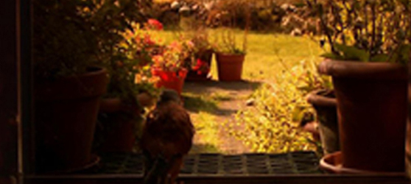

Deadline for receipt of applications: **Friday 17th October 2014, 17:00**.

Reel Art is an Arts Council scheme designed to provide film artists with a unique opportunity to make highly creative, imaginative and experimental documentaries on an artistic theme. Operated in association with Filmbase and the Jameson Dublin International Film Festival, Reel Art will support two films with a grant of **€70-80,000** per project.

Updated guidelines for Reel Art 2014, together with application forms for the scheme are available for download from the website [www.filmbase.ie/reelart](http://newsletter.artscouncil.ie/17xca9zxkab1eenva7sbzm?a=6&p=47682585&t=17684704)  as are details of previous Reel Art projects.

Visual artists in prisons scheme

Maximum awarded: **€2,400**

This scheme provides financial support to selected visual artists to conduct workshops over a period of 10 days in the education units in any of the Republic’s prisons.

Writers in schools scheme

Maximum awarded: **€304**

The Writers in Schools Scheme part-funds visits by writers and storytellers to schools throughout the Republic of Ireland.

[Writers in prisons scheme](http://www.artscouncil.ie/funds/Writers-in-prisons-scheme/)

Maximum awarded: **€1,000**

The scheme offers writers the opportunity to work with prisoners in prison/detention centres and complements an existing arts and education programme in the Education Units within the prison system.

Publications / Title - by – Title scheme

Maximum award: **€35,000**

**Opens 12th August**

Application deadline: **11th September 2014 17:30**

The Publications/Title by Title scheme assists publishers in the production of literary titles and journals.

More info of the above funding and contact details at <http://miniurl.com/4b062>

**\_\_\_\_\_\_\_\_\_\_\_\_\_\_\_\_\_\_\_\_\_\_\_\_\_\_\_\_\_\_\_\_\_\_\_\_\_\_\_\_\_\_\_\_\_\_\_\_\_\_\_\_\_\_\_\_\_\_\_\_\_\_\_\_\_\_\_\_\_\_\_\_\_\_\_\_\_\_\_\_\_\_\_\_\_\_\_**

|  |
| --- |
| **Announcing the Jack Harte Bursary** |

|  |
| --- |
| **We are delighted to announce the Jack Harte Bursary -**  **Awarded by the Irish Writers Centre in association with the Tyrone Guthrie Centre.**  The Irish Writers’ Centre and the Tyrone Guthrie Centre at Annaghmakerrig have come   together to offer a two-week fully resourced Writer-in-Residence Bursary to take place in spring 2015. The award is named in honour of Jack Harte, founder of the Irish Writers Centre, in celebration and acknowledgement of his contribution to Irish literature.  **Who Can Apply:**  This is an open call to writers resident in Ireland with a proven track record and at least one book of fiction or short stories published by a recognised publisher.  **How to Apply:** Applications are accepted by email only to [director@writerscentre.ie](mailto:director@writerscentre.ie) .    **Application Deadline:**  **26th September, 2014 at 5pm**.  No late applications will be considered. Applications will be acknowledged  For all other queries, please contact [events@writerscentre.ie](mailto:events@writerscentre.ie)  **\_\_\_\_\_\_\_\_\_\_\_\_\_\_\_\_\_\_\_\_\_\_\_\_\_\_\_\_\_\_\_\_\_\_\_\_\_\_\_\_\_\_\_\_\_\_\_\_\_\_\_\_\_\_\_\_\_\_\_\_\_\_\_\_\_\_\_\_\_\_\_\_\_\_\_\_\_\_\_\_\_\_\_\_\_\_\_** |

**Arts Council – Festival & Events Scheme**

Deadline 15 September

This scheme provides funding of up to €40,000 to small arts festivals or events being held throughout the country. The Arts Council is the national agency for funding, developing and promoting the arts in Ireland. The Council recognises that the arts have a central and distinctive contribution to make to society. The Arts Council announces Round 1 of the Festivals and Events Scheme (FES). The Council recognises the distinctive role arts festivals play in sustaining a vibrant arts profile at a local level. Festivals provide opportunities for audiences and artists to experience new work and ways of making work. The Council acknowledges the valuable contribution made by voluntary committees in developing these festivals. The scheme will be open to multi-disciplinary festivals, single artform festivals. Events may be one-off projects or programmed over a number of months (e.g. a concert series). There are three strands of funding available: Strand 1: Up to €10,000 Strand 2: Between €10,001 and €20,000 Strand 3: Between €20,001 and €40,000 How to Apply All applications for funding must be submitted via the Arts Council online services website. Visit the Arts Council website for further information and guidelines [www.artscouncil.ie](http://www.artscouncil.ie)

# Crafts Council of Ireland – External Exhibitions Fund

# **Deadline 19 September**

[Design & Crafts Council of Ireland](http://www.dccoi.ie/)

**The Crafts Council of Ireland is inviting funding proposals for exhibitions featuring Irish craft in Ireland or abroad.**

**The Crafts Council of Ireland (CCoI) is the main champion of the craft industry in Ireland, fostering its growth and commercial strength, communicating its unique identity and stimulating quality design, innovation and competitiveness. CCoI’s  activities are funded by the Department of Enterprise, Trade and Innovation via Enterprise Ireland.**

The Design & Crafts Council of Ireland’s (DCCoI) External Exhibitions Fund has been established to assist the development of high-quality, independent exhibitions run by individuals, organisations or groups including DCCoI Guilds, Associations, Networks & Societies (GANS).

Funding proposals are invited for exhibitions featuring Irish craft/design in Ireland or abroad. This annual fund will support a small number of professionally produced exhibitions featuring Irish craft/design in Ireland or abroad. This call will fund activities due to take place in 2015. The maximum that will be allocated to any individual proposal is €5,000.

Projects must demonstrate match-funding, revenue or funding from other sources. Exhibitions can be in recognised venues or one-off/ site-specific projects, organised by individuals, groups, partnerships or organisations.

In 2015, priority will be given to exhibitions that engage in collaborative practice and/or explore the future landscape, role and value of craft and design and its wider relationships with innovation.

### How to Apply

[Visit the Council website](http://www.dccoi.ie/craftspeople/opportunities/funding-proposals-invited-for-exhibitions-featuring-irish-craft-design-in-i)  http://www.dccoi.ie/

**Visual Arts Curator Residency Scheme Deadline 5:30pm, Thursday 11 September 2014**

The Arts Council announces the deadline for the Visual Arts Curator Residency Scheme, 2014.

The closing date for receipt of applications is Thursday 11 September at 5.30pm.

The purpose of this scheme is to offer visual arts curators the opportunity to research and develop their practice, while developing a year-long work programme in partnership with multi-disciplinary venues and local authorities. The specific content of the work programme will be designed by the curator in collaboration with the venue and local authority.

This scheme is not conceived to fill a gap in core programming, but instead might expand on, or offer something distinctive, to an existing visual arts programme in a multi-disciplinary venue.

The aims of this scheme are:

* to offer opportunities to curators[[1]](http://newsletter.artscouncil.ie/1myrt2il7da14rbsgtdsq9?a=6&p=47856861&t=17684704" \o ") across the country to research and develop a programme of work relevant to the progression of their own practice;
* to offer opportunities to multi-disciplinary venues[[2]](http://newsletter.artscouncil.ie/pvi1c972rol14rbsgtdsq9?a=6&p=47856861&t=17684704" \o ") and local authorities to develop curatorial practice in their geographical area;
* to encourage a considered approach to, and innovative ways of, engaging local audiences with high-quality contemporary visual arts at local/regional level;
* to encourage the development of long-term planning and sustainability of high-quality visual arts activities within multi-disciplinary venues;
* to encourage a co-ordinated approach between key arts providers at local/regional level.

The maximum amount awarded to each successful application will be **€20,000**.

The scheme is now open for applications.

All applications must be submitted using the Arts Council’s online services website.  Application forms submitted via email/post/fax will not be accepted.

For further information on the Visual Arts Curator Residency Scheme please contact Kate O'Donnell, Visual Arts & Architecture Officer on 01 6180236 or by email at [kate.odonnell@artscouncil.ie](mailto:kate.odonnell@artscouncil.ie)

### Arts Council's Artist in the Community Scheme - Bursary Award 2014: Collaborative Dance

Deadline:  **24th October (5pm)**

Web: [www.create-ireland.ie](http://www.create-ireland.ie)

The Arts Council Artist in the Community Scheme Bursary Award 2014: Collaborative Dance aims to support individual professional dance artists working in the area of collaborative dance or with groups of non dancers . This is the fifth year that the Arts Council has provided a **€10,000** bursary award as part of the Artist in the Community Scheme, which is managed by Create. This year for the first time the focus will be art-form specific as opposed to focusing on a social or community context.

The Bursary Award of **€10,000** provides the selected artist with the time and resources to carry out research, and to reflect on and re-consider the questions associated with creating dance work with non dancers or those who are not professionally trained.It is expected that the successful applicant will share the learning arising from the Bursary with the wider dance community and collaborative arts sector.

Create will work in partnership with Dance Ireland in providing information sessions and on the selection process and details on the dates for the sessions will be announced on

[www.create-ireland.ie](http://r20.rs6.net/tn.jsp?f=001m_3HN6KNk-_p-lEuScFgF_UY6xVp4vNqCYfvI774zvPzJRuBVTviPmR0bhAhK4xEKkLqk7V1qB_nULsCET51obKdkVpOPftQSyf2BNHXd1BoAPVYvcbRMI1B7QkcCrbu_mu-VoT-BtoybBJfGs04rnhjzQLVlM0W6QdTSBfnhdquK8poMUydjg==&c=b3o4qYKY5DRFLoW7qs_or2gpbar_P3jxMjR9oNqZJG2uemcoc1SpNQ==&ch=V-wO1x9Pap4bDqoHf7ynABRbSPcRgTxqSOSf5GaLTsQnSKlON1G8ww==)

[www.danceireland.ie](http://r20.rs6.net/tn.jsp?f=001m_3HN6KNk-_p-lEuScFgF_UY6xVp4vNqCYfvI774zvPzJRuBVTviPm0ghaMIryxQhbp6zz_4FBRPZoJ39XwBzTHvIiwNKwoqGC3HlWBx8OoT_FRc84jCQPxI1SDDUIxecWzdycw44t-qt8veRy9wAaNlt5_BmQ9CXqmDkwkLs6I=&c=b3o4qYKY5DRFLoW7qs_or2gpbar_P3jxMjR9oNqZJG2uemcoc1SpNQ==&ch=V-wO1x9Pap4bDqoHf7ynABRbSPcRgTxqSOSf5GaLTsQnSKlON1G8ww==)

For further information on the application, contact Katherine Atkinson, Professional Development, [support@create-ireland.ie](mailto:support@create-ireland.ie)

**\_\_\_\_\_\_\_\_\_\_\_\_\_\_\_\_\_\_\_\_\_\_\_\_\_\_\_\_\_\_\_\_\_\_\_\_\_\_\_\_\_\_\_\_\_\_\_\_\_\_\_\_\_\_\_\_\_\_\_\_\_\_\_\_\_\_\_\_\_\_\_\_\_\_\_\_\_\_\_\_\_\_\_\_\_**

**European Union Prize for Cultural Heritage / Europa Nostra Awards**

[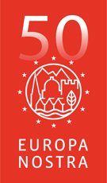](http://www.europanostra.org/)

The **European Union Prize for Cultural Heritage / Europa Nostra Awards** is Europe’s most prestigious prize in the heritage field. Every year, it honours the most outstanding heritage achievements from all over Europe. It recognises the excellence and dedication by architects, craftsmen, cultural heritage experts, volunteers, schools, local communities, heritage owners and the media. It stimulates creativity and innovation, through the power of example.

**DEADLINE 15th OCTOBER 2014**

In 2015, the Awards will be given to up to 30 remarkable heritage projects and initiatives in four categories. Up to seven will be selected as Grand Prix winners and receive **€10,000 each**. One will get the Public Choice Award.

More info at <http://www.europanostra.org/apply-for-an-award-2015/>

**European Cultural Foundation – STEP travel grants – ongoing**

[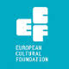](http://www.google.ie/url?url=http://sideshow-circusmagazine.com/research/funding-sources/step-beyond-travel-grants&rct=j&frm=1&q=&esrc=s&sa=U&ei=nYDGU4mnCtKe7AbIhYDoCw&ved=0CCAQ9QEwBg&usg=AFQjCNGnthfC8RitJQx109ixVGPR1pNiAA)

**STEP Beyond Travel grants fund up and coming artists and cultural workers – giving priority to individuals up to 35 years and/or in the first 10 years of their career – to travel between EU and countries bordering the EU.**

There is no deadline for this grant scheme, so you can apply at any time but at least one month before your planned travel. The selection process takes up to one month.

For more information on how to apply, a list of eligible travel destinations and to access the application form, go to the “how to apply guidelines”: [http://tinyurl.com/p26gd7n](http://tinyurl.com/p26gd7n%20)

These guidelines are also available in Russian but please note that the final application has to be in English. You can also access the application form directly here – [ecflabs.org/step-beyond-apply?gids[]=4707#group\_step\_1](http://ecflabs.org/step-beyond-apply?gids%5b%5d=4707#group_step_1)

**\_\_\_\_\_\_\_\_\_\_\_\_\_\_\_\_\_\_\_\_\_\_\_\_\_\_\_\_\_\_\_\_\_\_\_\_\_\_\_\_\_\_\_\_\_\_\_\_\_\_\_\_\_\_\_\_\_\_\_\_\_\_\_\_\_\_\_\_\_\_\_\_\_\_\_**

**The Golden Fleece Award - Call for Applications for the 2015 Award**

****

The Golden Fleece Award aims to support and promote the diversity of contemporary Irish creativity in the arts and crafts. Its mission is to help artists of innovative talent, needing support at strategic stages of their careers. Applicants will normally have been born on the island of Ireland and must maintain a strong connection with Ireland. They should be artists or researchers working in the area of figurative visual art or of the traditional crafts.

Closing date for applications: **Friday, 21st November 2014**

Full details of submission requirements and procedures can be found on our website at www.goldenfleeceaward.com.

# \_\_\_\_\_\_\_\_\_\_\_\_\_\_\_\_\_\_\_\_\_\_\_\_\_\_\_\_\_\_\_\_\_\_\_\_\_\_\_\_\_\_\_\_\_\_\_\_\_\_\_\_\_\_\_\_\_\_\_\_\_\_\_\_\_\_\_\_\_\_\_\_\_\_\_\_\_\_\_\_\_\_\_\_\_\_\_

**Of Interest**

# \_\_\_\_\_\_\_\_\_\_\_\_\_\_\_\_\_\_\_\_\_\_\_\_\_\_\_\_\_\_\_\_\_\_\_\_\_\_\_\_\_\_\_\_\_\_\_\_\_\_\_\_\_\_\_\_\_\_\_\_\_\_\_\_\_\_\_\_\_\_\_\_\_\_\_\_\_\_\_\_\_\_\_\_\_\_\_

[](http://www.newrosspianofestival.com/NRPF/)



Beatrice Berrut (Photo: Aline Fournier)

The ninth New Ross Piano Festival will turn its attention to music for piano and wind instruments, as we welcome **Cassiopeia Winds**, a group of five bright stars from Dublin. They will partner our pianists in music by Mozart, Rimsky-Korsakov, Caplet and Poulenc. And what wonderful pianists we have for you this year! Young titans **Lise de la Salle** from France and **Joseph Moog** from Germany will make their Irish débuts, while seasoned Singaporean **Melvyn Tan** will make a long-overdue return. **Beatrice Berrut** is making waves in Switzerland. Artistic Director **Finghin Collins** needs no introduction.

This year we also launch a new project: The **Ros Tapestry Suite**. The first five panels of the Ros Tapestry have inspired the creation of five new solo piano pieces (each lasting five minutes) by five very different Irish composers: **Sebastian Adams, Elaine Agnew, Gerald Barry, John Kinsella and Gerry Murphy**. Five world premieres by five pianists across the weekend. This is an additional reason, if any is needed, not to miss this wonderful weekend.

Help us spread the word – follow us on Twitter and like us on Facebook. We will launch on board the Dunbrody Famine Ship in New Ross on Wednesday August 20th at 6.30pm. All are welcome.

<http://www.newrosspianofestival.com/>

**Sculpture in Context 2014 at the National Botanic Gardens**

4th September – 17th October 2014  
National Botanic Gardens, Glasnevin, Dublin 9.  
Opening Times: Monday – Friday 9am to 5pm; Saturday & Sunday 10am – 6pm; (Botanic Garden Café open daily)

Sculpture in Context 2014 returns once again to the National Botanic Gardens this September, showcasing the work of Irish and international artists, it is the largest and most exciting outdoor sculpture exhibition in Ireland.

For the duration of the exhibition, the 50 acre botanical paradise will be transformed into a magnificent outdoor gallery, providing a striking backdrop for the sculptures. This quiet oasis is just 3.5 km from the centre of Dublin City and provides a wonderful venue for artists to create work in response to specific surroundings. Visitors will discover sculptures in the most unexpected and surprising places. Over 150 sculptures will be displayed in the gardens, ponds, Great Palm House, and Curvilinear Range of glasshouses. Smaller pieces are exhibited in the gallery above the visitors’ centre.

Sculpture in Context is a thought provoking, inspirational and unique experience and offers an unparalleled opportunity to view Ireland’s well established and most promising artists.

This year will see the addition of a major new award – The New Ireland Assurance Sculpture Award

Guided Tours: Saturdays at 3pm, and Tuesday mornings at 10.30 for the duration of the exhibition.

ADMISSION FREE | Car Park €2.

The National Botanic Gardens are located 3 Kilometres North of Dublin city centre, 10 minutes by bus from O’Connell Street (Nos. 4, 9 and 83)

For further information please see [www.sculptureincontext.com](http://lists.visualartists.ie/lt.php?c=1200&m=4239&nl=1&s=d3c261c0eeb6b48867f449d29e09414b&lid=94008&l=-http--www.sculptureincontext.com)

**Arts Council Announces Appointment of New Arts Director**

The Arts Council has announced the appointment of Liz Meaney as its new Arts Director to join its senior management team.

Liz is an experienced Arts Manager, who has worked in both the private and public sectors. Following graduation she worked with the Cork Film Centre, Cork Film Festival and was Development Officer with the Kino Cinema. She was Manager of the Galway Film Centre from 1997-2001. Returning to Cork in 2001 she took up her position as Cork City Council Arts Officer and was involved both in the bid for the nomination and the realisation of Cork as European Capital of Culture 2005.

During her time with Cork City Council their support for the arts has increased as part of overall budget provision, particularly post European Capital of Culture 2005. These levels of support were substantially maintained in recent years, with increased support for project, bursary and arts in context funding being announced in 2013.

She has served on the boards of Cork 2005 European Capital of Culture, the Association of Irish Festivals and Events, and Cork Midsummer Festival. She has served as Chair of the Association of Local Authority Arts Officers. Her experience ranges from the commissioning of large scale public spectacles with audiences in excess of 150,000 to long term strategic planning for the arts as well as grand aid management and execution.

Capital cultural development projects on which she has worked include Triskel Christchurch, the Munster Literature Centre and the Guesthouse Project Space. Events managed include A Cork Christmas Celebration, winner of Best Festival in Ireland from Chamber Ireland in 2010, to Culture Night, which attracted in excess of 37,000 individual visits to venues in 2012. She also was responsible for the Arts & Cultural Strategy of Cork City Council 2011 – 15.

Liz has commissioned cultural work for the Shanghai Expo 2010 and for the Cork programme during the Irish tenure as President of the EU 2013.

A graduate of University College Cork, Liz has a Masters in Irish History. She is a certified IPI Project Manager, and has a Diploma in Irish Local Government Studies through the Institute of Public Administration. She was selected by Business to Arts for a leadership development programme in 2007.

Liz will take up her position as Arts Director for Performing and Local Arts in October.

[www.artscouncil.ie](http://lists.visualartists.ie/lt.php?c=1204&m=4243&nl=1&s=e784eec6bf8bb9680747b324b9c9eee1&lid=93874&l=-http--www.artscouncil.ie)